

**student project management**

**Software Requirement Specification**

– Hanoi, May 2022 –

Record of changeS

|  |  |  |  |
| --- | --- | --- | --- |
| Date | A* M, D | In charge | Change Description |
| 13/May | A | HuongNC | Do I.1 – Overview Introduction |
| 13/May | A | HoangVM | Do I.2a,b – Overview System functions: Screen flow, screen details |
| 13/May | A | DatPT | Do I.2c,d - Overview System functions: User authorization & non-screen function |
| 13/May | A | KhanhTQ | Do II.1 – Function requirement: Feature Common |
| 13/May | A | TraiCV | Do II.2 - Function requirement: Feature Admin |
| 19/May | M | HoangVM | Modified context diagram |
| 2/June | M | KhanhTQ | Modified I.2.c,d - User authorization & non-screen function |
| 2/June | M | KhanhTQ | Modified II.2.b – Change setting detail layout |
| 2/June | A | KhanhTQ | Do II.3.a, b – Subject setting list, details |
| 4/June | A | HoangVM | Do II.2.c,d - Overview System function |
| 4/June | A | TraiCV | Do II.1.f,g – Reset password, change password |
| 4/June | M | TraiCV | Modified II.1.a – Home - Layout |
| 4/June | A | HuongNC | Do II.2 –System functions: User List, User Details |
| 4/June | A | DatPT | Do II.3.c, d – Iteration list, Iteration details |
| 12/June | A | KhanhTQ | Do II.3.e,f,g – Criteria List, Criteria Details, Class List |
| 18/June | A | HoangVM | Do II.3.h-Class List/ II.4.a,b-Milestone List, Milestone Details |
| 18/June | M | KhanhTQ | Modified II.3.e,f,g-Criteria List, Criteria Details, Class List |
| 18/June | A | TraiCV | Do II.4.c,d,e,f - Class User List, Class User Details, Class User Export, Class User Import |
| 18/June | A | HuongNC | Do II.4.g,h –System functions: Team List, Team Details |
| 18/June | A | DatPT | Do II.5.a,b – Feature List, Feature details |
| 19/June | M | DatPT | Modified II.5.a,b – Feature List, Feature details- add screen layout |
| 30/June | A | KhanhTQ | Do II.4.i,j,k – Loc Evaluation, Team Evaluation, User Evaluation |
| 8/July | A | TraiCV | Do II.5.c,d,e,f – Function List, Function Details, Function Export, Import |
| 8/July | A | HuongNC | Do II.5.g,h –System functions: Issue List, Issue Details |
| 8/July | A | HoangVM | Do II.4,l – Milestone Sync, II.5,i – Issue Sync |
| 18/July | M | HoangVM | Modified I.1- Overview context diagram |

*A - Added M - Modified D - Deleted

**Table of Contents**

I. Overview 5

1. Introduction 5

2. System Functions 6

II. Functional Requirements 12

1. Common 12

a. Home 12

b. User register 12

c. User login …………………………………………………………………………………………………………………………….13

d. Dashboard …………………………………………………………………………………………………………………………..14

e. User profile …………………………………………………………………………………………………………………………15

f. Reset password…………………………………………………………………………………………………………………….16

g. Change password ………………………………………………………………………………………………………………..17

2. Admin 18

a. Setting list …………………………………………………………………………………………………………………………19

b. Setting details …………………………………………………………………………………………………… …………….20

c. Subject list ………………………………………………………………………………………………………… ……………..20

d. Subject details ………………………………………………………………………………………………… ………………..21

e. User list …………………………………………………………………………………………………………… ……………….22

f. User details ………………………………………………………………………………………………………………………..22

3. Author……………………………………………………………………………………………………………………………………23

a. Subject setting list ……………………………………………………………………………………………………………….23

b. Subject setting details …………………………………………………………………………………………………………24

c. Iteration list ………………………………………………………………………………………………………………………..25

d. Iteration details ………………………………………………………………………………………………………………….25

e.Criteria list……………………………………………………………………………………………………………………………26

f.Criteria details………………………………………………………………………………………………………………………27

g.Class list……………………………………………………………………………………………………………………………….28

h**.**Class details…………………………………………………………………………………………………………………………29

4.Trainer……………………………………………………………………………………………………………………………………30

a.Milestone List………………………………………………………………………………………………………………………30

b.Milestone Details…………………………………………………………………………………………………………………31

c.Class User List……………………………………………………………………………………………………………………...32

d.Class User Details…………………………………………………………………………………………………………………32

e.Export Class User………………………………………………………………………………………………………………….33

f.Import Class User………………………………………………………………………………………………………………….34

g.Team List………………………………………………………………………………………………………………………………35

h.Team Details…………………………………………………………………………………………………………………………36

5.Student…………………………………………………………………………………………………………………………………….37

a.Feature List…………………………………………………………………………………………………………………………..37

b.Feature Details…………………………………………………………………………………………………………………….38

# I. Overview

## 1. Introduction

This paper discusses the method of the management informationization in higher education. On the basis of a comprehensive investigation and analysis on the student management in higher education, we establish the models of the college students' management informationization by adopting the advanced information technology, and construct the student management informationization platform. Moreover, we analyze the characteristics of the informationization management in higher education, and elaborate the methods to solve the difficulties confronting in the students management of the higher education. Finally, the key method and technology to carry out the informationization management platform are presented.

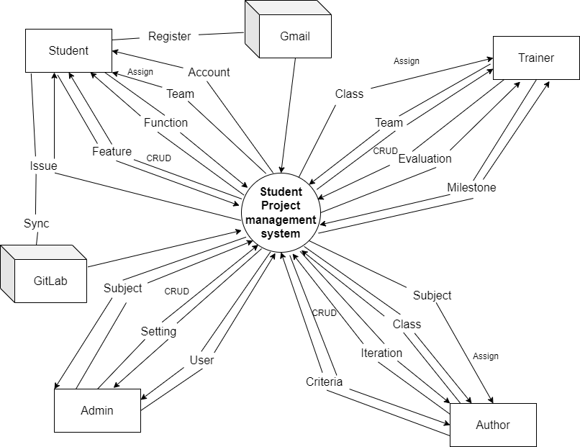

## 2. System Functions

#### a. Screen Flow

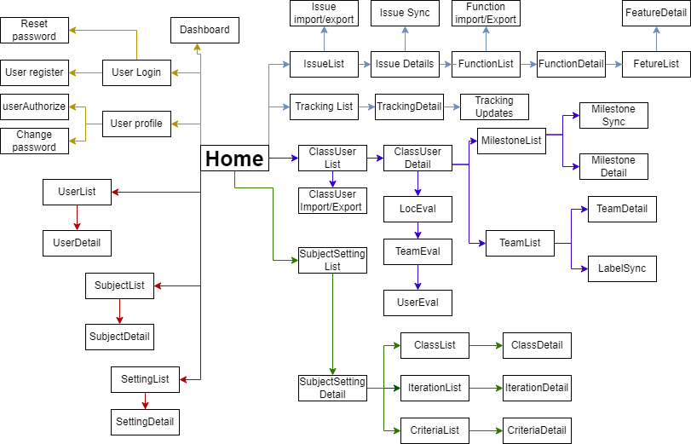

#### b. Screen Details

|  |  |  |  |
| --- | --- | --- | --- |
| **#** | **Feature** | **Screen** | **Description** |
| 1 | Common | Home | The composite screen contains the link to all functions |
| 2 | Common | User register | Register new account |
| 3 | Common | User Login | Login to system |
| 4 | Common | Reset password | Reset account password |
| 5 | Common | User Authorization | Authorize user account |
| 6 | Common | Dashboard | Statistics and announcements |
| 7 | Common | User profile | User information |
| 8 | Common | Change password | Change account password |
| 9 | Student | Feature list | Show a table of the characteristics of a function |
| 10 | Student | Feature details | A detail information |
| 11 | Student | Function List | See function list |
| 12 | Student | Function details | See function details |
| 13 | Student | Function import/export | Import or export a function |
| 14 | Student | Issue list | See issue list |
| 15 | Student | Issue import/export | Import or export an issue |
| 16 | Student | Issue details | See issue details |
| 17 | Student | Issue sync | Synchronize issue on gitlab |
| 18 | Student | Tracking list | See tracking list |
| 19 | Student | Tracking details | See tracking detail |
| 20 | Student | Tracking update | Change tracking information |
| 21 | Trainer | Class User list | See class user list |
| 22 | Trainer | Class user import/export | Import or export a class user |
| 23 | Trainer | Class user details | See detail class user |
| 24 | Trainer | Team list | See list of team |
| 25 | Trainer | Team Details | Detail of team |
| 26 | Trainer | Label sync | Sync issue type and issue status of team |
| 27 | Trainer | Milestone List | See milestone list |
| 28 | Trainer | Milestone Details | See milestone detail |
| 29 | Trainer | Milestone Sync | Sync milestone on gitlab |
| 30 | Trainer | Loc eval | Loc evaluation |
| 31 | Trainer | Team eval | Team evaluation |
| 32 | Trainer | User eval | User evaluation |
| 33 | Author | Subject setting list | See subject setting list |
| 34 | Author | Subject setting details | See subject setting detail |
| 35 | Author | Iteration list | See list iteration |
| 36 | Author | Iteration details | See detail iteration |
| 37 | Author | Criteria List | See list criteria |
| 38 | Author | Criteria Details | See criteria detail |
| 39 | Author | Class list | See class list |
| 40 | Author | Class Details | See class detail |
| 41 | Admin | Setting list | See setting list |
| 42 | Admin | Setting details | See setting detail |
| 43 | Admin | User list | See user list |
| 44 | Admin | User details | See user detail |
| 45 | Admin | Subject list | See subject list |
| 46 | Admin | Subject details | See subject detail |

#### c. User Authorization

|  |  |  |  |  |  |
| --- | --- | --- | --- | --- | --- |
| **Screen** | **Admin** | **Author** | **Trainer** | **Student** | **User** |
| Home | x | x | x | x | x |
| User Register | x | x | x | x | x |
| Setting List | x |  |  |  |  |
| Setting Details | x |  |  |  |  |
| User Login | x | x | x | x | x |
| Reset Password | x | x | x | x | x |
| User Authorization | x |  |  |  |  |
| Dashboard | x | x | x | x |  |
| User Profile | x | x | x | x | x |
| Change Password | x | x | x | x | x |
| User List | x |  |  |  |  |
| User Details | x |  |  |  |  |
| Subject List | x |  |  |  |  |
| Subject Details | x |  |  |  |  |
| Subject Setting List |  |  |  |  |  |
| Access all data | x |  |  |  |  |
| Access assigned subject only |  | x |  |  |  |
| Subject Setting Details |  |  |  |  |  |
| Access all data | x |  |  |  |  |
| Access assigned subject only |  | x |  |  |  |
| Iteration List |  |  |  |  |  |
| Access all data | x |  |  |  |  |
| Access assigned subject only |  | x |  |  |  |
| Iteration Details |  |  |  |  |  |
| Access all data | x |  |  |  |  |
| Access assigned subject only |  | x |  |  |  |
| Criteria List |  |  |  |  |  |
| Access all data | x |  |  |  |  |
| Access assigned subject only |  | x |  |  |  |
| Criteria Details |  |  |  |  |  |
| Access all data | x |  |  |  |  |
| Access assigned subject only |  | x |  |  |  |
| Class List |  |  |  |  |  |
| Access all data | x |  |  |  |  |
| Access assigned subject only |  | x |  |  |  |
| View assigned class only |  |  | x |  |  |
| Class Details |  |  |  |  |  |
| Access all data | x |  |  |  |  |
| Access assigned subject only |  | x |  |  |  |
| View assigned class only |  |  | x |  |  |
| Milestone List |  |  | x |  |  |
| Milestone Details |  |  | x |  |  |
| Milestone Sync |  |  | x |  |  |
| Team List |  |  | x |  |  |
| Team Details |  |  | x |  |  |
| Label Sync |  |  | x |  |  |
| Class User List |  |  | x |  |  |
| Class User Import/Export |  |  | x |  |  |
| Class User Details |  |  | x |  |  |
| Feature List |  |  |  |  |  |
| Access data of assigned classes' teams |  |  | x |  |  |
| Access data of allocated’s team only |  |  |  | x |  |
| Feature Details |  |  |  |  |  |
| Access data of assigned class |  |  | x |  |  |
| Access data of allocated’s team only |  |  |  | x |  |
| Function List |  |  |  |  |  |
| Access data of assigned classes' teams |  |  | x |  |  |
| Access data of allocated’s team only |  |  |  | x |  |
| Function Details |  |  |  |  |  |
| Access data of assigned classes' teams |  |  | x |  |  |
| Access data of allocated’s team only |  |  |  | x |  |
| Function Import/Export |  |  |  |  |  |
| Access data of assigned classes' teams |  |  | x |  |  |
| Access data of allocated’s team only |  |  |  | x |  |
| Issue List |  |  |  |  |  |
| Access data of assigned classes' teams |  |  | x |  |  |
| Access data of allocated’s team only |  |  |  | x |  |
| Issue Import/Export |  |  |  |  |  |
| Access data of assigned classes' teams |  |  | x |  |  |
| Access data of allocated’s team only |  |  |  | x |  |
| Issue Details |  |  |  |  |  |
| Access data of assigned classes' teams |  |  | x |  |  |
| Access data of allocated’s team only |  |  |  | x |  |
| Issue Sync |  |  |  |  |  |
| Access data of assigned classes' teams |  |  | x |  |  |
| Access data of allocated’s team only |  |  |  | x |  |
| Tracking List |  |  |  |  |  |
| Access data of assigned classes' teams |  |  | x |  |  |
| Access data of allocated’s team only:  - Can create new tracking for unevaluated functions |  |  |  | x |  |
| Tracking Details |  |  |  |  |  |
| Access data of assigned classes' teams |  |  | x |  |  |
| Access data of allocated’s team only |  |  |  | x |  |
| Tracking Updates |  |  |  |  |  |
| Access data of assigned classes' teams |  |  | x |  |  |
| Access data of allocated’s team only but:  - Not allow to update the evaluated or rejected plan  - Can add/edit update(s) for the evaluated functions |  |  |  | x |  |
| Loc Evaluation |  |  |  |  |  |
| Access allocated team' data only (view only) |  |  |  | x |  |
| Access data of the assigned classes' teams |  |  | x |  |  |
| Team Evaluation |  |  |  |  |  |
| Access allocated team' data only (view only) |  |  |  | x |  |
| Access data of the assigned classes' teams |  |  | x |  |  |
| User Evaluation |  |  |  |  |  |
| Access allocated team' data only (view only) |  |  |  | x |  |
| Access data of the assigned classes' teams |  |  | x |  |  |

In which:

* Admin:

Person that has highest level of authorize in system, can do everything and complete access to all table, all screens, functions in system

* Author:

Author can only access data in some functions that is assigned to, in tables: subject_setting, iteration, criteria, class,

* Trainer:

Trainer can access data of the assigned classes' teams or assigned class in tables: milestone, team, class_user, feature, function, issue, tracking, loc_evaluation, iteration_evaluation, team_evaluation and member_evaluation

But author can only view data of class table

* Student:

Student can access allocated team' data only in tables: feature, function, issue.

But for tracking table :

- Not allow to update the evaluated or rejected plan

- Can create new tracking for unevaluated functions

- Can add/edit update(s) for the evaluated functions

And can only view data in table: loc_evaluation, iteration_evaluation, team_evaluation and member_evaluation

* User:

Lowest level of authorization, only access to function or screen that don’t even need a role to access like : Home, User Register, User login, User profile, Reset password, Change password

#### d. Non-Screen Functions

|  |  |  |  |
| --- | --- | --- | --- |
| **#** | **Feature** | **System Function** | **Description** |
| 1 | Common | User Authorization | Authorize admin, author, student, trainer to access what part of system. |
| 2 | Trainer | Milestone Sync | Sync milestones list with the GitLab |
| 3 | Trainer | Label Sync | Label Sync: labels of the Issue Types & Issue Status |
| 4 | Student | Issue Sync | Sync issues list with the GitLab |

# II. Functional Requirements

## 1. Common

### a. Home

* *Function trigger: enter the website*
* *Function description: actors/roles, purpose, interface, data processing, etc.*
  + *Roles: all people*
  + *Purpose: show information, basic layout, function of website*
  + *Data processing: get data about design, some basic about the website, system, not contain anything related to user data*
* *Screen layout:*

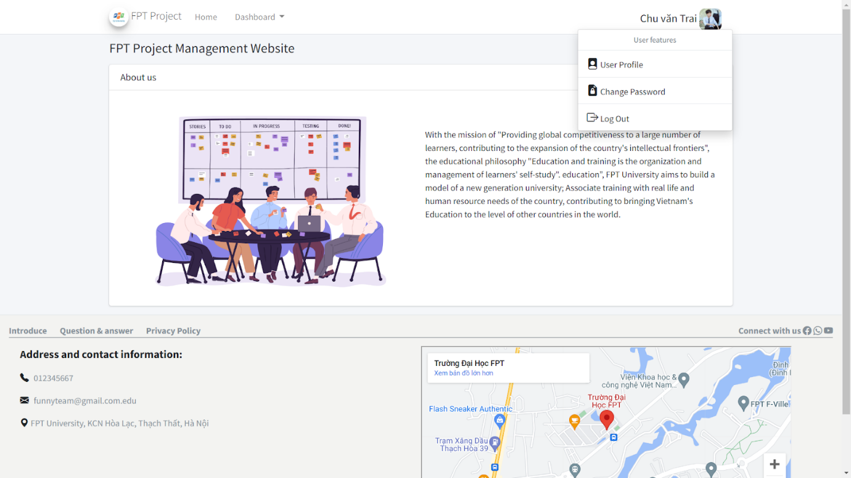

* *Function Details:* 
  + *This is the first part of the website where all people go in website first see*
  + *It has header, a sidebar to naviagtion, and a footer for basic information to contact with us. It just the most basic one as you not login into the website*

### b. User register

* Function trigger: click on the button Register in Home page
* Function description:
  + Roles: all people
  + Purpose: let user regist new account to access more website information
  + Data processing: process data within table “user”, add 1 more row in this table if user register success.
* Screen layout

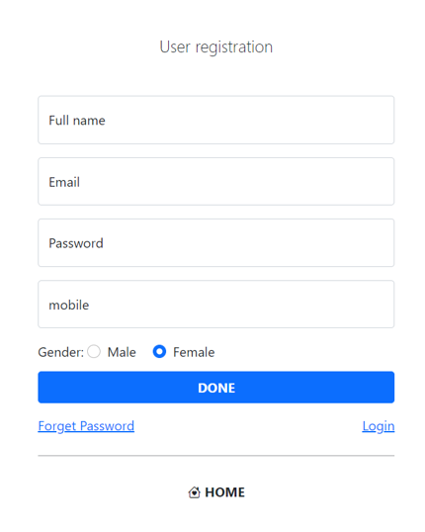

* Function details:
  + You need to register an account to login into this website
  + Each account will have own role, given by admin to access suitable data, place in website
  + As normal, you need to fill in fullname, email, gender, mobile, password … to register an account. If register success, you will get an email notification to verify your account. From now, you can use it to login into the website
  + But maybe you will not register success because wrong information or repeated information.

**c. User login**

* Function trigger: click on the button Login in Home page
* Function description:
  + Roles: User
  + Purpose: let user with a registered account can login into the website
  + Data processing: system will compare the user entered account and data in table “user” in database. If user input correct account, user already login into website.
* Screen layout

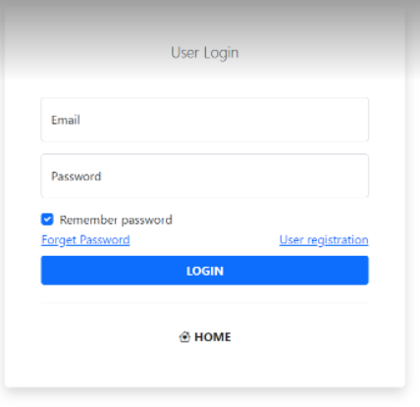

* Function details:
  + After registered an account and verify it, you need to login to access into the website.
  + System will check data in database to decide you can login or login failed
  + Login success and you are directed to your own home page.
  + Login failed you are notified and need to re-login.

**d. Dashboard:**

* Function trigger:

Click on “Dashboard” on side bar after login to system

* Function description
* Roles: User
* Purpose: get list of action to manage each part of system: setting, user, …
* Data: combination of other table setting, user, class, …
* Screen layout

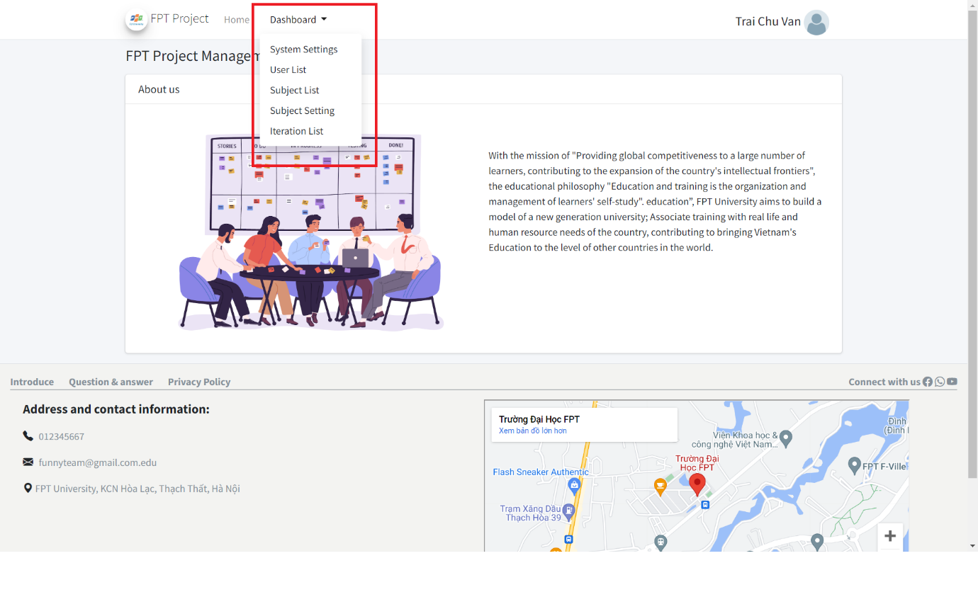

* Function details:
  + After login, user have dashboard on side bar.
  + Dashboard contain some fields like setting, user
  + Also have chart for user to see.

**e. User profile:**

* Function trigger: after you successful login into system, click on the “User profile” in the home page to see, edit, update your user profile
* Function description:
  + Roles: User
  + Purpose: list the user information, let them change, add their information like: name, gender, avatar, mobile, …
  + Data processing: system get data from what you use when registered or your last update in “user” in database
* Screen layout

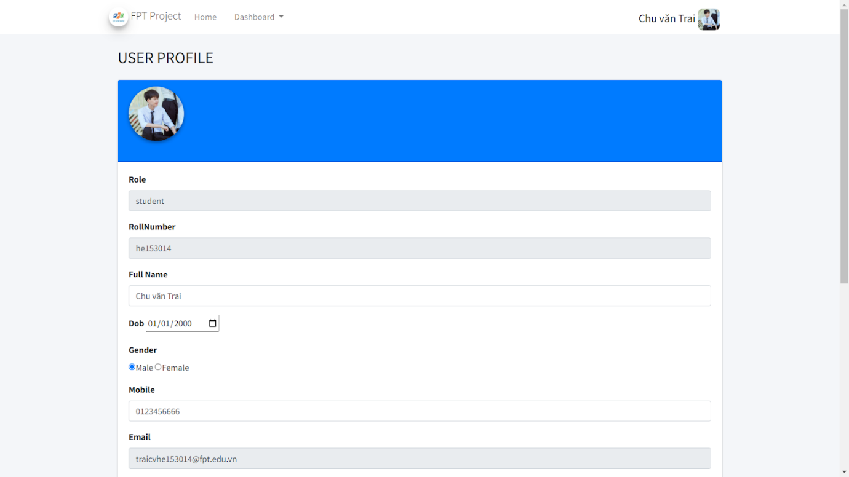

* Function details:
  + After login success, you can see button to get to User profile in home page
  + This page has many fields like: email,, full name, avatar, gender, mobile, facebook, …
  + You can change, add or just see these information. After change, you need to click “Submit” to update new information to database
  + Sometimes it may raise error if you enter information that is not valid or repeated like same email to other account.

**f. Reset password.**

• Function trigger: click on the button Register in Home page, then click on the "Forget Password" link.

• Function description:

o Roles: all users.

o Purpose: Allows users to reset their new password when they forget their old password

o Data processing: change password data in "user" table

• Screen layout:

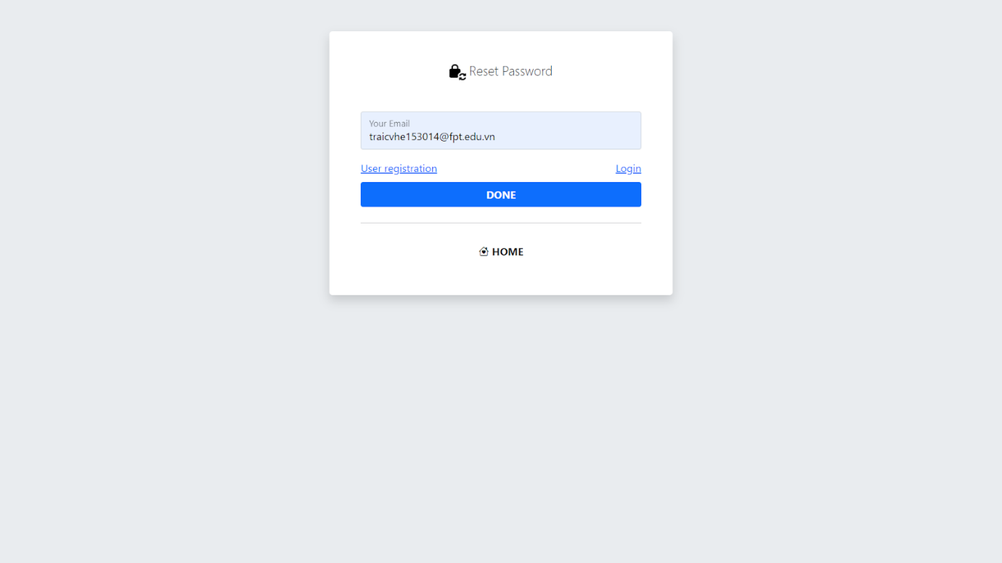

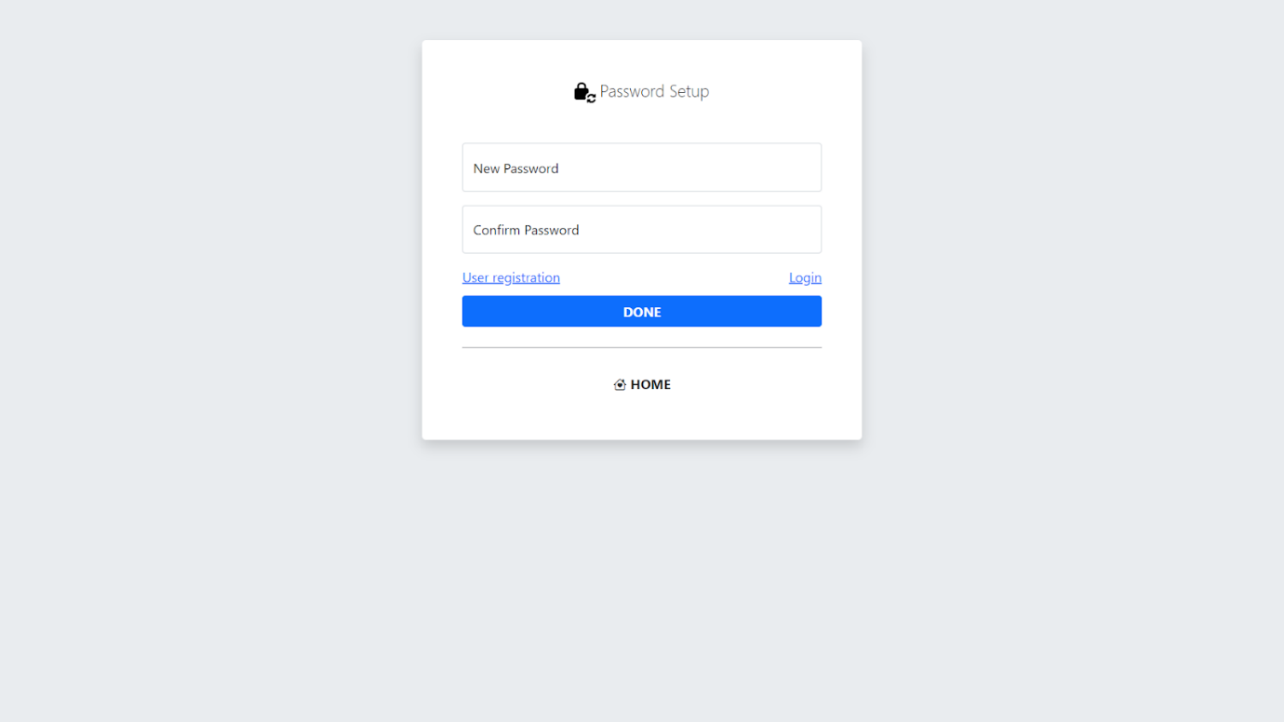

* Function details:

- Enter user email in password reset screen then system will send reset confirmation email to user.

- After confirming the email, you will go to the password setup page, the user will enter a new password.

**g. Change password.**

• Function trigger: After logging in on the home page, the user clicks on the avatar and the "change password" button will appear.

• Function description:

o Roles: logged in user.

o Purpose: The user wants to change the password.

o Data processing:  update their new password in the "users" database table.

• Screen layout:

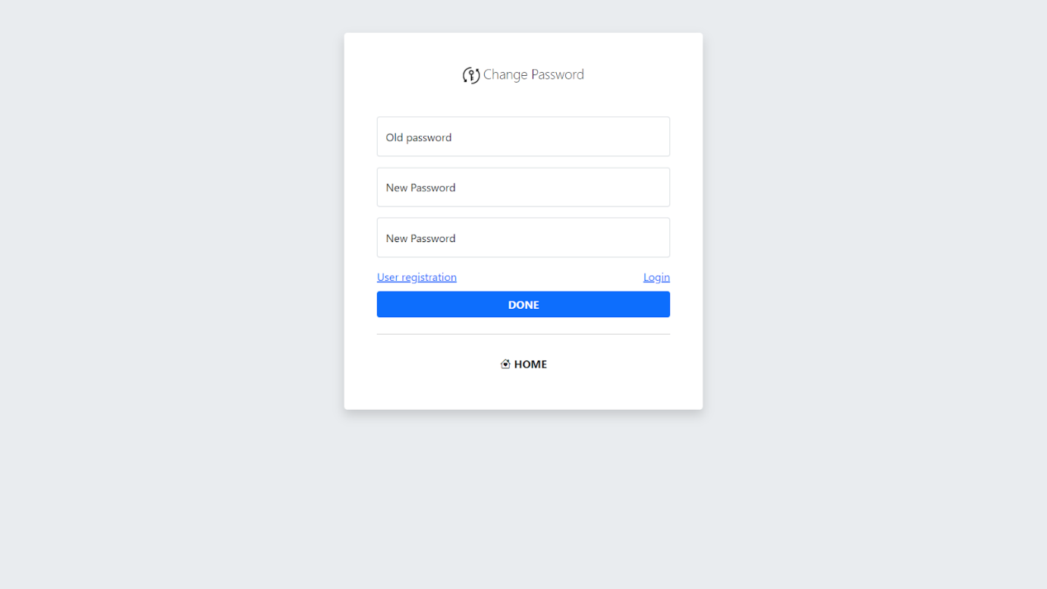

• Function details:

- Input the old password and enter the new password that the user wants.

- After changing the password, the system will update the new password to the database.

## 2. Admin

### a. Setting List

• Function trigger: at the Home page, after successfully logging in with the Admin account, there will be a link named Dashboard and clicking on it, when reaching the Dashboard screen, there will be a link named "System settings" when clicking will lead the user to the Function Setting screen List.

• Function description: help admin control setting functions (setting.roles, setting.issue_type, setting.issue_status). The interface includes the following functions: filter data (filter setting type, filter statuses, enter type setting name), display setting data (id, setting type, name, order, value, status) , action (edit, deactivate) and add settings.

* Screen layout: 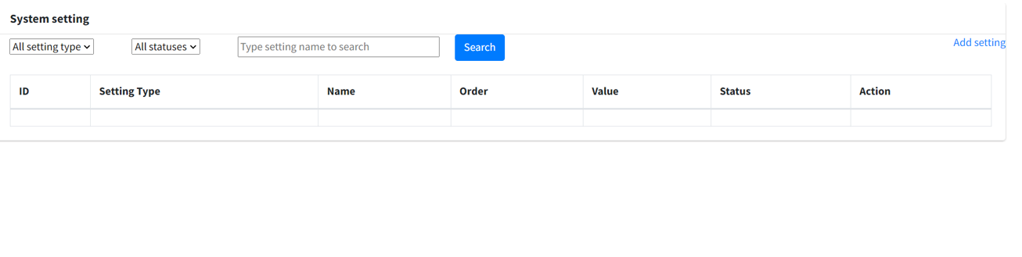

• Function Details:

* Display all settings for admin: id, type, name, order, value, status
* Use data in table “setting” in database
* Filter by type, status or name
* Add new settings
* Can link to details, update page.
* Can delete setting

**b. Setting details**

* Function trigger: continue the Function trigger of "2.a. Function Setting List" when at the screen of Setting List each line of setting information will have an Action column in the column there will be an "edit" button which will lead to the Setting Details screen of the user selected setting.

• Function description: View and edit detailed data of each "setting". the interface will display data in the value of input and admin can edit that data (Setting type,name,order, value,description ),"Status" has 2 options active or Inactive , after editing can be done. Click the submit button to save the edit.

• Screen layout:

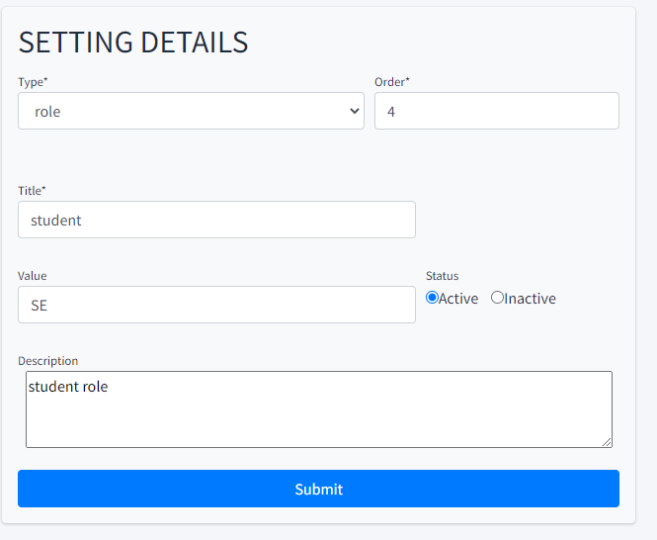

• Function Details:

* See details of setting
* Can also upadte setting in here: update setting type, setting value, display order, status, description
* By click on submit, data will be update in table “setting” in database

### c.  Subject List

• Function trigger:  at the Home page, after successfully logging in with the Admin account, there will be a link named Dashboard and clicking on it, there will be a link named "Subjects" when clicking will lead the user to the Function Subject list screen.

•    Function description:

      o Roles:Admin

      o Purpose: Show all subject for admin to view, control and change status. Viewable              data include Subject Id, code, name, the author which assigned to the subject. Admin also be able to see which subject are currently don’t have in charge author or the author already been remove. Search by subject code or name, filter status

• Screen layout:

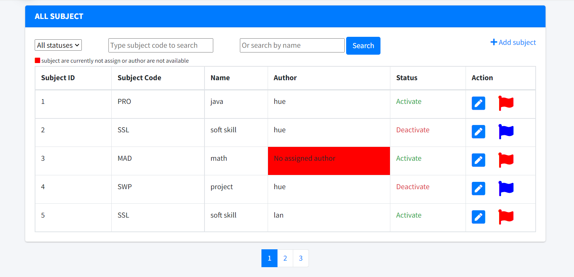

• Function Details:

* Display subject info for admin: id, code, name, author, status
* Use data in table “subject” and “user” in database
* Filter by Subject code, status or name
* Can link to details, update and add new subject page.
* Can change status of subject

### d.  Subject Details

* Function trigger:  continue the Function trigger of "2.c. Function Subject List" when at the screen of Subject List each line of setting information have an Action column contain an "edit" icon which will lead to the Subject Details screen of the selected subject. If add new subject then there is an “add new” button on the top right of the table

• Function description: View and edit detailed data of each "Subject". the form will display data in the value of input and admin can edit that data (SubjectCode, name, author),"Status" has 2 options active or Inactive . Click the submit button and confirm the alert to save the edit.

• Screen layout:

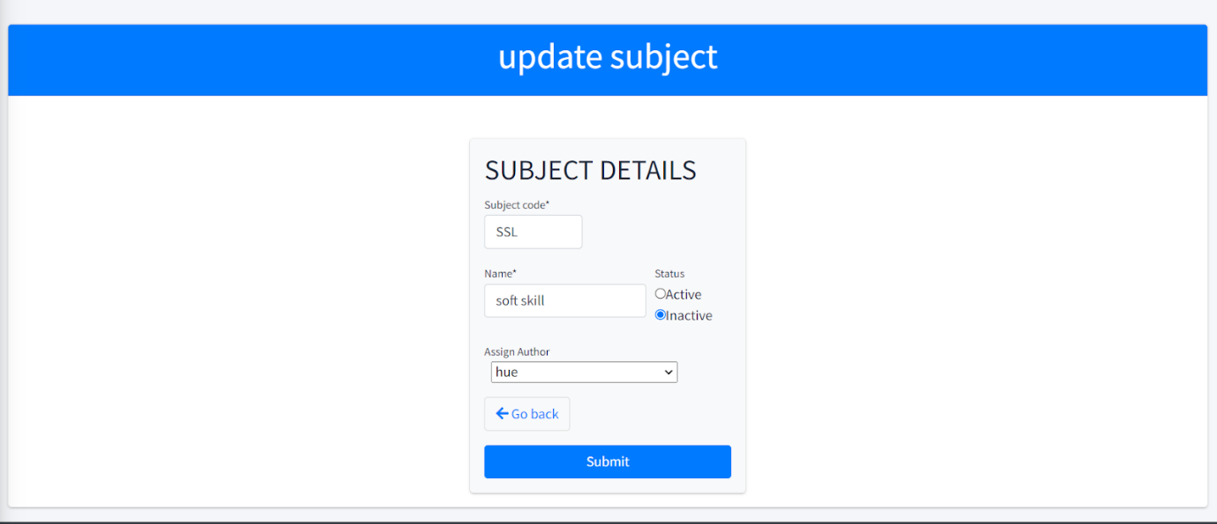

• Function Details:

* See details fields of  a subject
* Can also update information  of subject in here: update subject code, subject name, status, assigned author
* By click on submit, web will prompt an alert and  data will be update in table “subject” in database

### e.  User List

• Function trigger:  at the Home page, after successfully logging in with the Admin account, there will be a link named Dashboard and clicking on it, when reaching the Dashboard screen, there will be a link named " User List " when clicking will lead the user to the Function User screen List.

• Function description: help admin control setting functions (user_id, full_name, email, mobile, role_id, status). The interface includes the following functions: filter data (filter All Roll , All Status, enter type name to search), display user data (id, name, email, mobile, role, status, action) , action (edit, deactivate) and add settings.

* Screen layout:

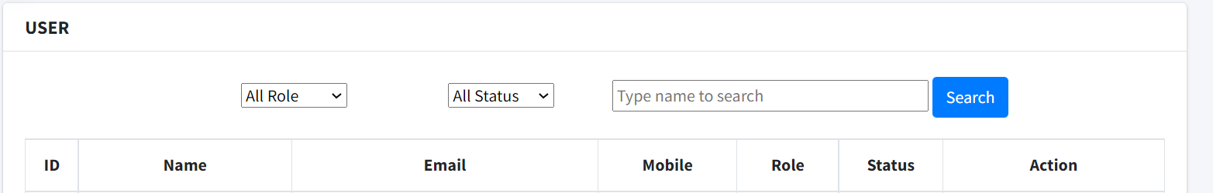

• Function Details:

* Display all User for admin: id, name, email, mobile, role, status, action
* Use data in table “User” in database
* Filter by type, status or name
* Can link to details, update page.
* Can delete logic User

**f.  User details**

* Function trigger:  continue the Function trigger of "Function User List" when at the screen of Setting List each line of setting information will have an Action column in the column there will be an "edit" button which will lead to the User Details screen of the user selected setting.

• Function description: View and edit detailed data of each "User". the interface will display data in the value of input and admin can edit that data (name, email, mobile, facebook, gender, status, role),"Status" has 2 options active or Inactive , after editing can be done. Click the submit button to save the edit.

• Screen layout:

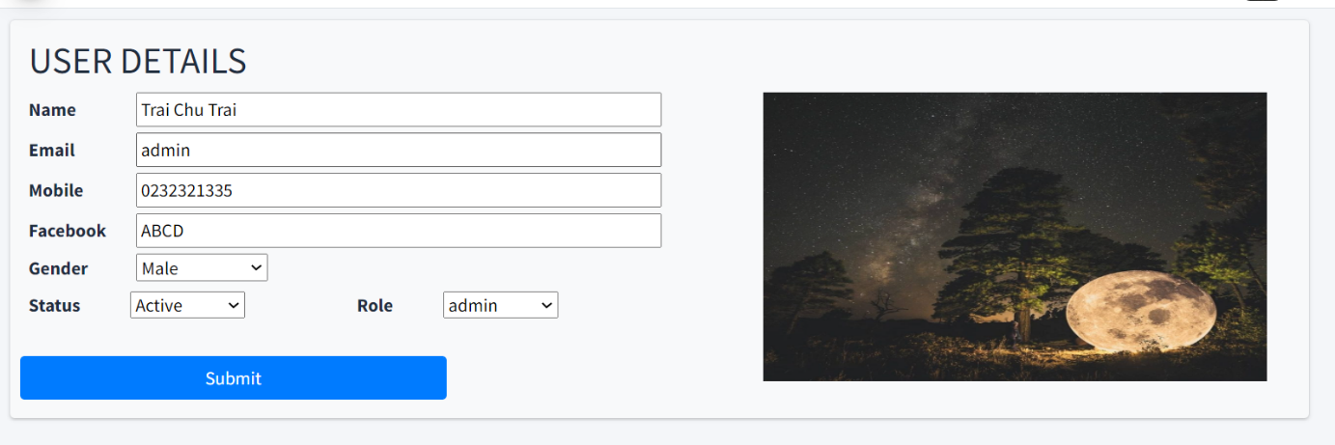

• Function Details:

* See details of User
* Can also upadte setting in here: (name, email, mobile, facebook, gender, status, role
* By click on submit, data will be update in table “user” in database

## 3. Author

### a. Subject Setting List:

* Function trigger:

At home page, after login with role Admin or Author, click “Dashboard” on header. Then you get a drop down list and click on “Subject Setting”

* Function description:

It help Admin or Author manage subject setting . Interface include all fields of table “subject_setting” in database: ID, subjectId, type, title, value, displayOrder, status.

It has button to edit, to add new and change status of a row.

It has filter and search place.

* Screen layout:

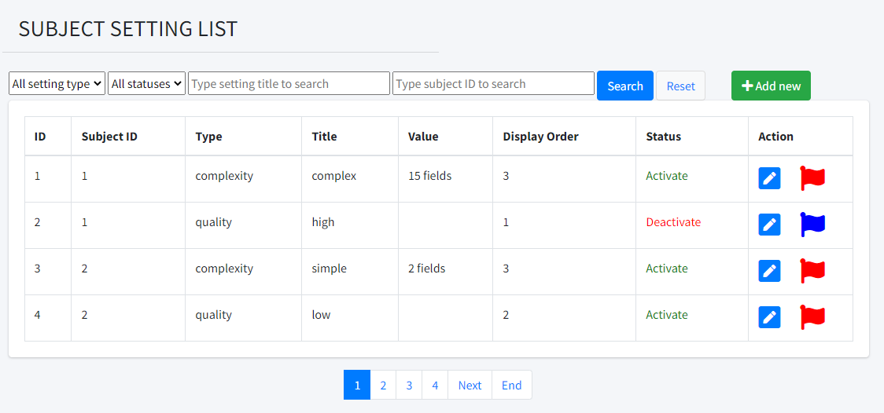

* Function details:
  + Display all subject setting
  + Display information of subject setting
  + Has filter and search field
  + Has add new, edit, change status

### b. Subject Setting Details:

* Function trigger:

At subject setting list screen, click on icon  to go to subject setting detail pages

* Function description:

Allow you to see detail and related information about subject and also update the information of that subject setting data you click on

* Screen layout:

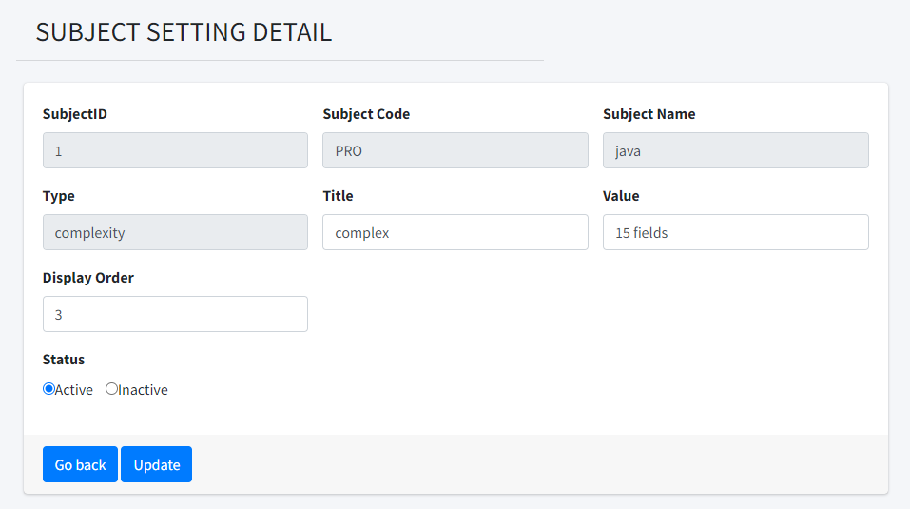

* Function details:
  + See details of subject setting
  + Allow you to change information and click “Update” button to update
  + You can click “Go back” if don’t want to change anything

### c. Iteration List

* **Function trigger:** When user(Admin/Author) login in system and following the link: <http://localhost:8080/G6_swp/iterationList> to come this screen.
* **Function description:** Just allow Admin or Author can see this screen, in this screen, Admin or Author can following these Iteration of each Subject and information about them like Subject ID, Iteration Name, Duration, Status.
* **Screen Layout:**

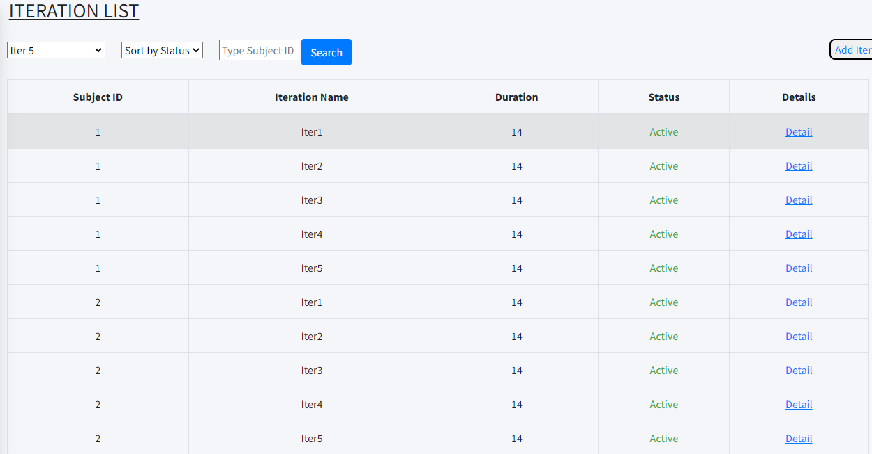

* **Function Details:**

About this screen, if you wanted to sort by Iteration Name, Status or Subject ID you just select and click button SEARCH to sort and find information that you want. Or when you want to add new Iteration, you just click on Add Iter -> this action will allow your add new iteration. About column Status you can change it, if it is Active you can change it to Inactive with 1 click. Finally, Detail will lead you to another screen to view all information of these subjects and you can also update them.

### d. Iteration details

* **Function trigger:** when you click to Detail of each subject in each iteration, you can get into screen to see all information of Iteration.
* **Function description:** Just allow Admin or Author can see this screen, in this screen, Admin or Author can update information about iteration like Subject ID, Iteration Name, Duration, Status or also delete them.
* **Screen layout:**

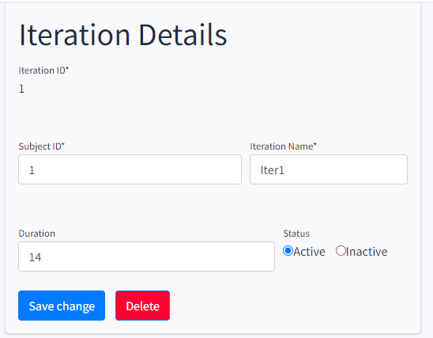

* **Function Details:** In this screen, it will show you all information that iteration have and you can change information.

### e. Criteria List

* Function trigger:

At home page, after login with role Admin, Author click on Criteria List in Dashboard are direct to Criteria List screen.

* Function description:

Show list of criteria, allow to change status, search

Has link to Criteria details and Add new

* Screen layout: mock-up prototype of the screen, sample below is for Manage Products screen

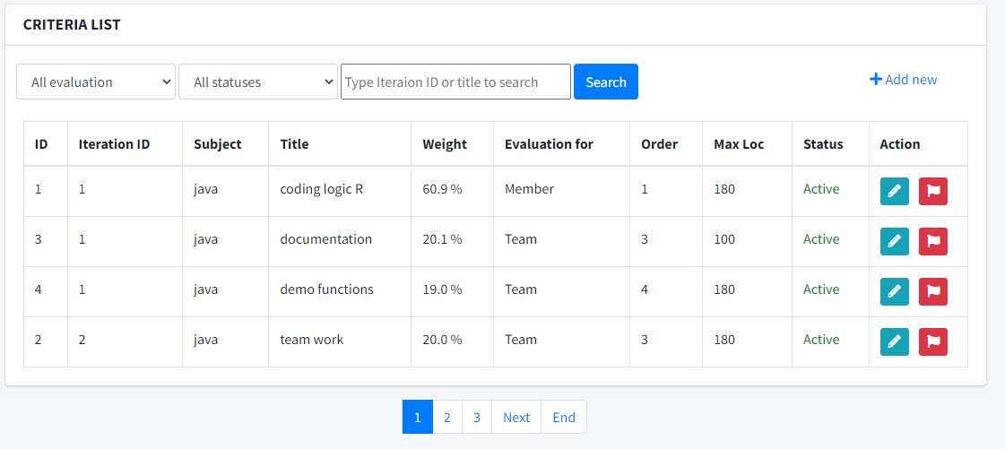

* Function Details:
  + See list of Criteria with data from table eval_criteria
  + Author can access criteria for assigned subject only
  + Admin can access all
  + Allow to change status , search
  + Has Link to details  and add new 

### f. Criteria Details

* Function trigger:

At Criteria List screen, click on icon  to go to Criteria Details pages

* Function description:

Allow yout to see details of a Criteria and related information about Iteration name, subject code, subject name

* Screen layout:

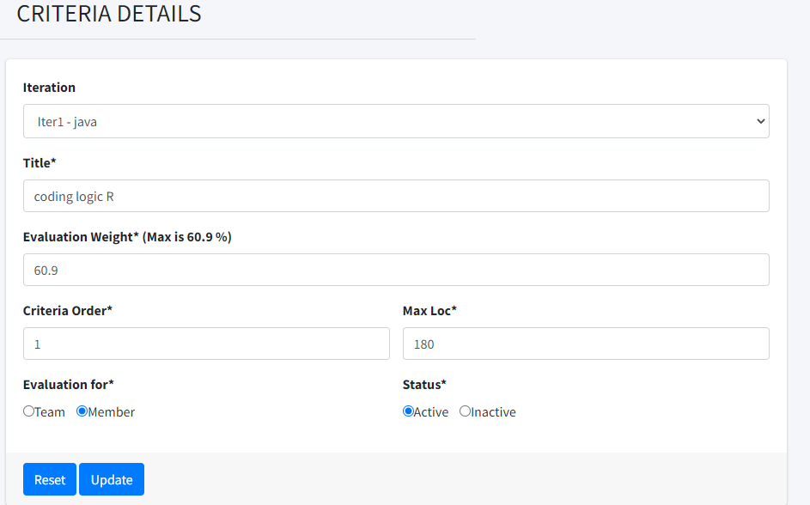

* Function details
* See details of a criteria.
* Get data from table eval_criteria and related foreign key to table iteration and subject
* Validation: Need to choose iteration, input title, evaluation weight, order, max loc and choose Evaluation for and status
* For evaluation weight, it has maximum because total for iteration of member or team is 100%

### g. Class List

* Function trigger:

At home page, after login with role Admin, Author or Trainer, click on Class List in Dashboard tou are direct to Class List screen.

* Function description:

Show list of Class, allow to change status, search.

Has link to Class Details and add new class

* Screen layout:

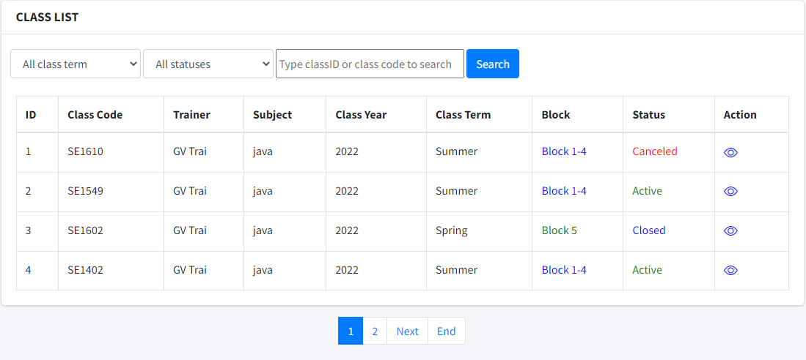

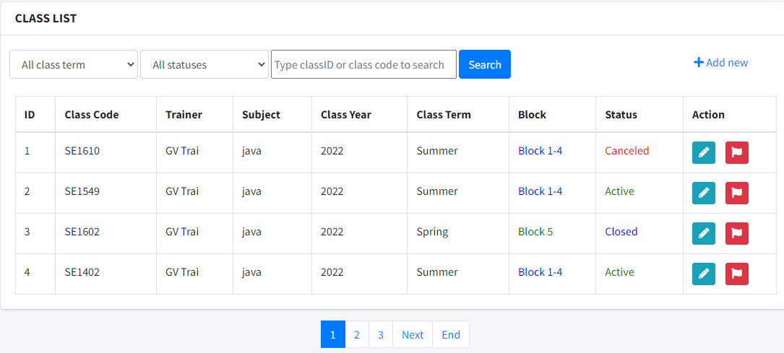

* Function details:
  + Show list of class:
    - Author can create or manipulate classes of assigned subjects
    - Trainer can access to view assigned classes only
    - Admin can access all class.
  + Allow to search, change status , link to details and add new
  + Get data from table class

### h. Class details

* Function trigger:

At home page, after login with role Admin, Author or Trainer, click on Class List in Dashboard. In Class list screen, click update icons(view icon if Trainer role) or add new link to navigate to Class details form

* Function description:

Show all information of a class, allow Admin to update all information of said class or add new class, Author can only update and add class of assign subject’s class only while trainer be able to view details.

* Screen layout

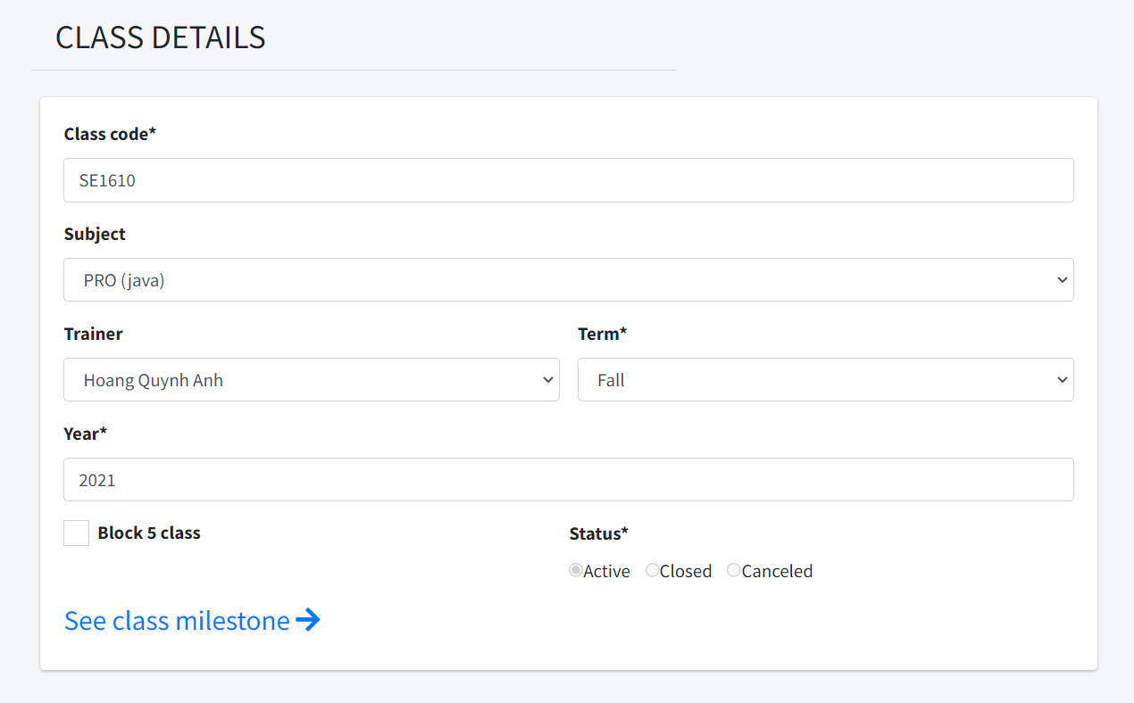

* Function details:
  + Show a class details information:
    - Author can create or manipulate classes of assigned subjects
    - Trainer can access to view assigned classes only, have a link to class’s milestone
    - Admin can access and add all class.

## 4. Trainer

### a. Milestone List

* Function trigger:

At home page, after login with role Trainer, click on Milestone in Dashboard that lead directly to Milestone List screen.

* Function description:

Show list of Milestone, allow to change status, filter.

Has link to Milestone Details and add new milestone

* Screen layout:

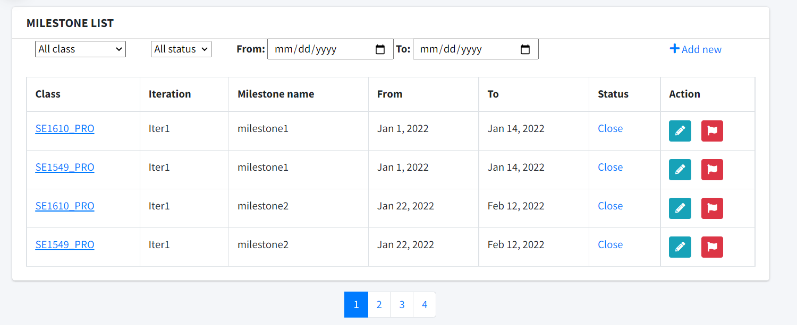

* Function details:
  + Show list of Milestone for trainer:
    - Trainer can see assigned class’s Milestone only
  + Allow to filter by class, status, date start and date end, change status , link to details and add new
  + Get data from table milestone, iteration and class

### b. Milestone details

* Function trigger:

At home page, after login with role Trainer, click on Milestone in Dashboard that lead directly to Milestone List screen, click on update icon or add new icon to acess to milestone details screen

* Function description:

Show all information of a milestone, allow trainer to create or manipulate assign class’s milestone only

* Screen layout:

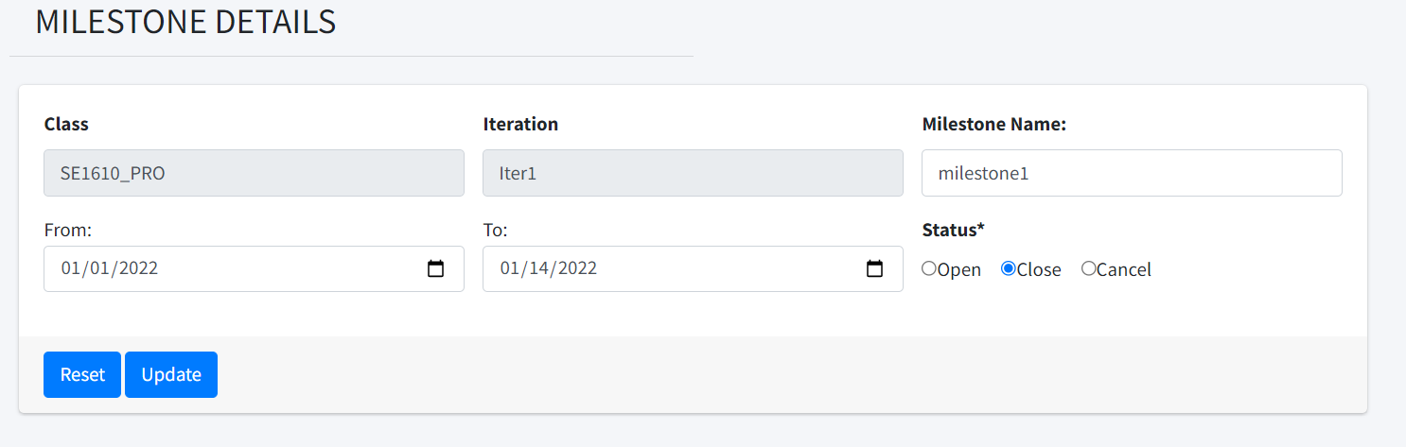

* Function details:
  + Show a milestone details information:
    - Trainer can see assigned class’s Milestone only
  + Add new milestone for a class in an iteration, cancel an milestone
  + Get data from table milestone, iteration and class

### c. Class User List

• Function trigger: at the Home page, after successfully logging in with the Trainer account, there will be a link named Dashboard and clicking on it, when you reach the Dashboard screen, there will be a link named "Class User" when you click on it. will lead the user to the "Class User List" screen.

• Function description: helps the Trainer to see the students and information that student has in a class. The interface includes the following functions: filter data, student information, index information page, actions (edit, deactivate) and Import/Export buttons.

• Screen layout:

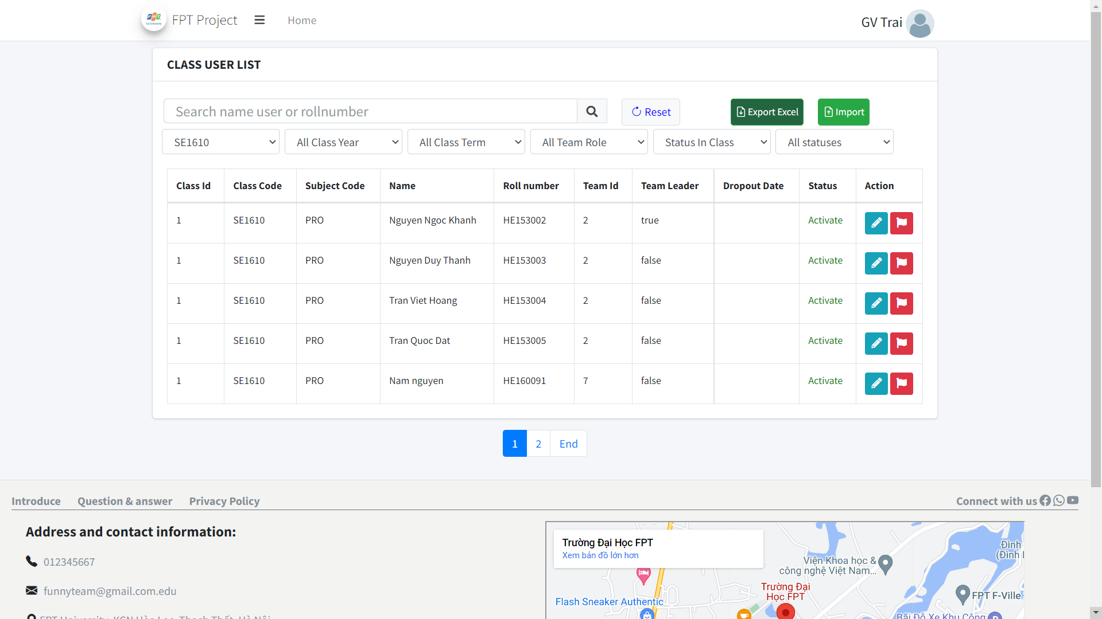

• Function Details:

o Display all students in the Trainer's class: Class Id, Class Code, Subject Code, Name, Roll number, Team Id, Team Leader, Dropout Date, Status.

o Using the data in the “Class User” table in the database

o Filter by Class code, Class year, Class Term, Team role, status in class, status and search roll number, name.

o Import/export Class User.

o Can link to details, update page.

o Can change student status

### d. Class User Details

• Function trigger: at the Home page, after successfully logging in with your Trainer account, there will be a link named Dashboard and clicking on it, when you reach the Dashboard screen, there will be a link named "Class User" when you click on it. will lead the user to the "Class User List" screen, then click the pen icon button to go to the Class user detail page.

• Function description: helps the Trainer to view detailed information of a student. The interface includes the following functions: display Class Code, Subject Code, Roll number, User name, Ongoing eval, Final pres eval, Final topic eval and can edit Team ID, Team leader, Dropout Date, User note.

• Screen layout:

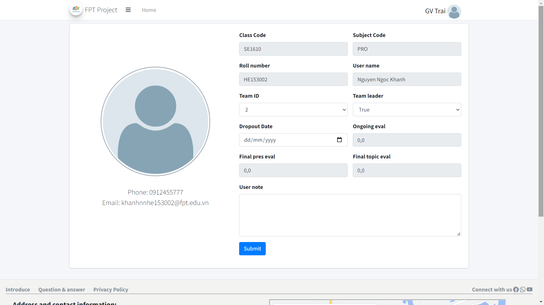

• Function Details:

o Display all details of a student: Class Code, Subject Code, Roll number, User name, Ongoing eval, Final pres eval, Final topic eval, Team ID, Team leader, Dropout Date, User note.

o Using the data in the “Class User” table in the database

o Can change student information

### e. Export Class User

• Function trigger: at the Home page, after successfully logging in with the Trainer account, there will be a link named Dashboard and clicking on it, when you reach the Dashboard screen, there will be a link named "Class User" when you click on it. will lead the user to the "Class User List" screen, then click the Export button. Excel will display the export screen.

• Function description: helps the Trainer to export an excel file with the desired list of user trainer classes. The excel file will be emailed to the trainer.

• Screen layout:

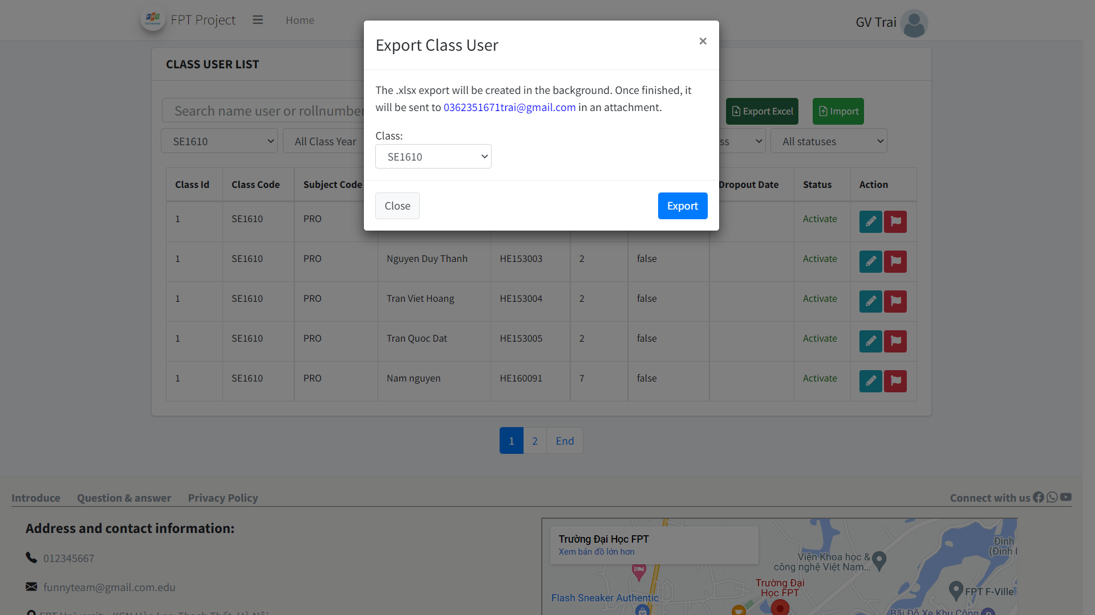

• Function Details:

o Display all the classes information of the Trainer and select the desired class to export the file.

o Using the data in the “Class User” table in the database

o Get the list of students in the user class in excel form.

### f. Import Class User

• Function trigger: at the Home page, after successfully logging in with your Trainer account, there will be a link named Dashboard and clicking on it, when you reach the Dashboard screen, there will be a link named "Class User" when you click on it. will lead the user to the "Class User List" screen, then clicking the Import button will display the Import screen.

• Function description: helps Trainer to import excel file with desired user trainer class list. The system excel file reads and updates the information in the user class table.

• Screen layout:

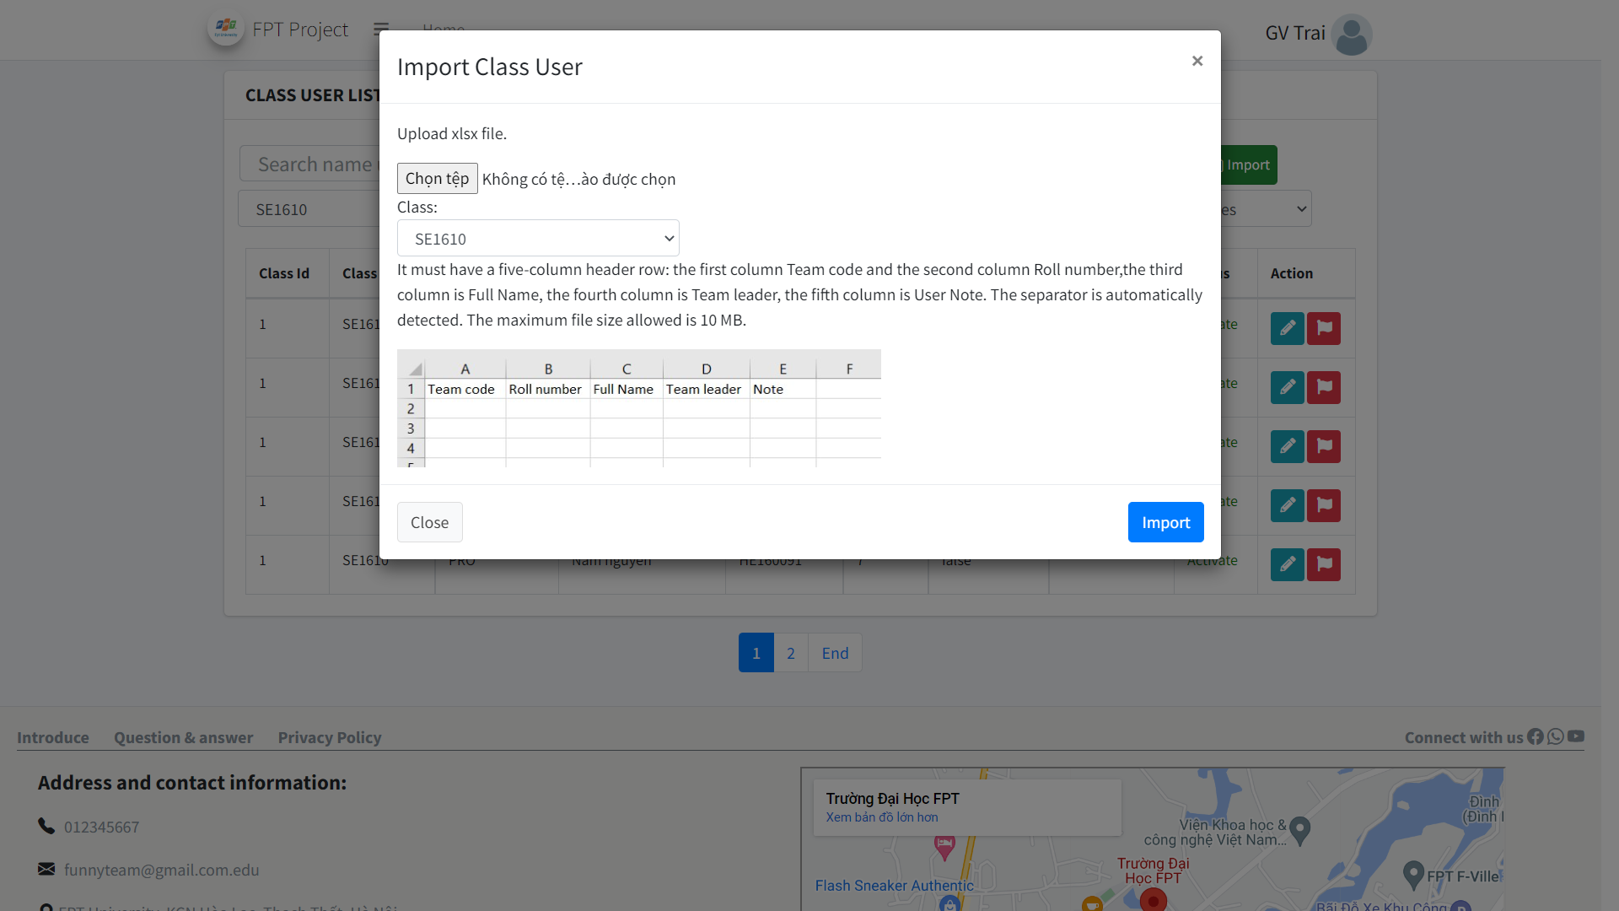

• Function Details:

o Display all the classes information of the Trainer and select the desired class to import the file.

o Use the data in the excel file to update the "Class User" table information in the database.

### g. Team List

• Function trigger:  at the Home page, after successfully logging in with the account, there will be a link named Dashboard and clicking on it, when reaching the Dashboard screen, there will be a link named "Team List" when clicking will lead the user to the Function Team screen List.

• Function description: help trainer control team functions (team_id, team_code, class_id, topic_code, gitlab_url, status). The interface includes the following functions: filter data (filter all class, filter statuses, enter Topic Name), display team data (Id, Team Code, Class Name, Topic Code, Topic Name, Gitlab URL, Status) , action (edit, deactivate) and add team.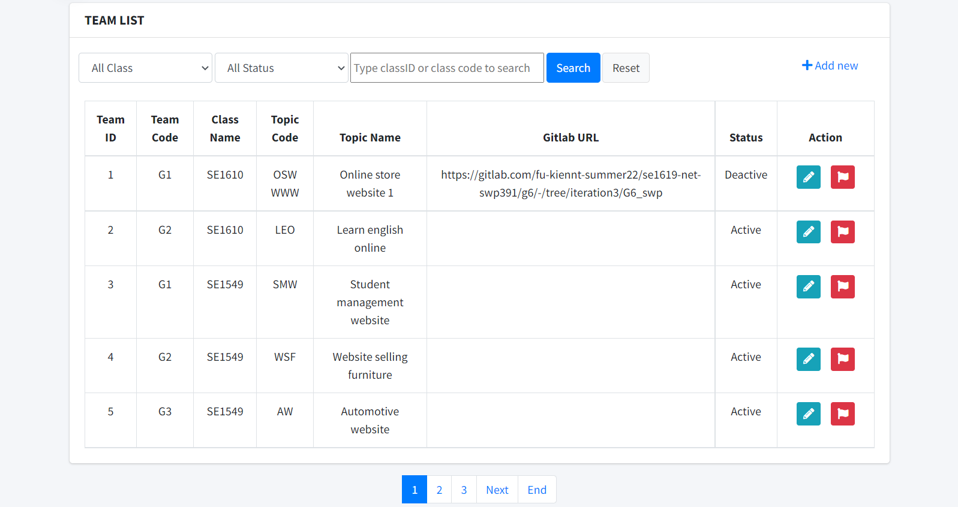

• Function Details:

O Display all settings for admin: Id, Team Code, Class Name, Topic Code, Topic Name, Gitlab URL, Status

o Use data in table “setting” in database

o Filter by type, status or name

o Add new settings

o Can link to details, update page.

O Can delete setting

### h. Team details

• Function trigger:  continue the Function trigger of " Function Team List" when at the screen of Team List each line of setting information will have an Action column in the column there will be an "edit" button which will lead to the Team Details screen of the user selected setting.

• Function description: View and edit detailed data of each "setting". the interface will display data in the value of input and admin can edit that data (Team code, Class, Topic Name, Topic Code, GitLab, Status ),"Status" has 2 options active or Inactive , after editing can be done. Click the submit button to save the edit.

• Screen layout:

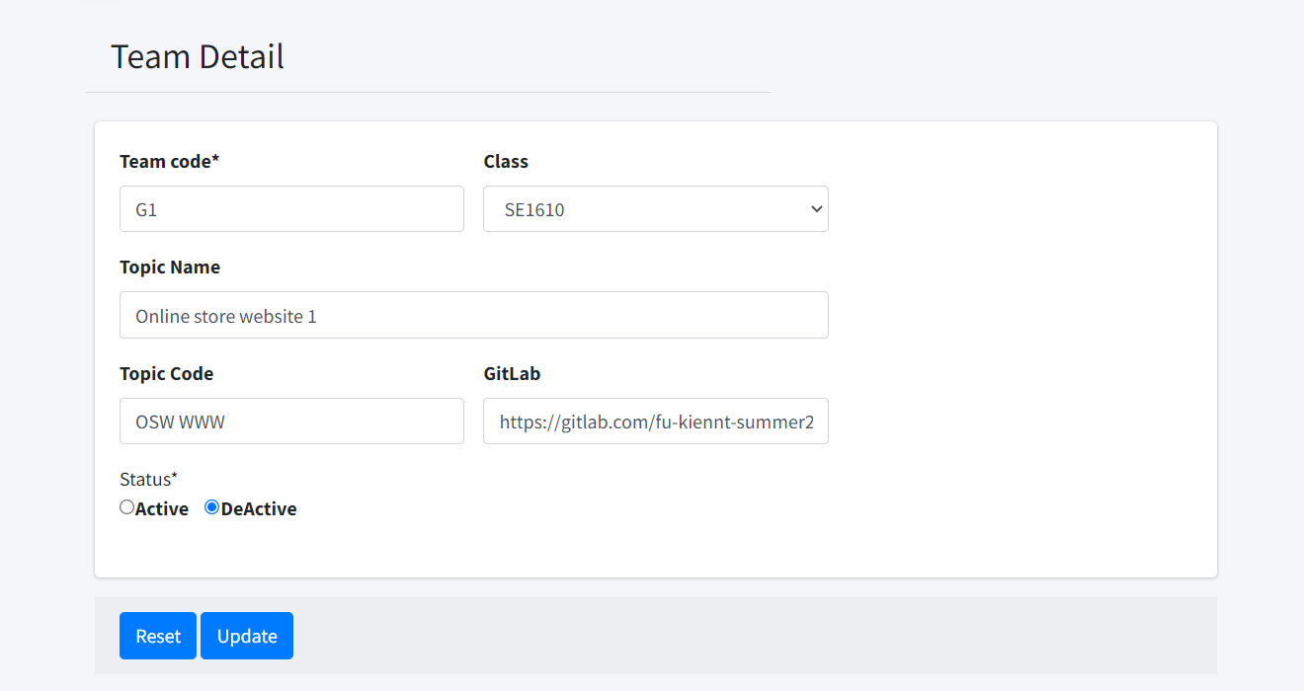

• Function Details:

O See details of Team.

O Can also upadte Team in here: update Team code, Class, Topic Name, Topic Code, GitLab, Status.

O By click on submit, data will be update in table “Team” in database.

### i. Loc Evaluation

* Function trigger:

In Tracking List screen, click on evaluate button to go to Loc Evaluation screen

* Function description:

Role student and trainer can access this screen

This screen show the loc evaluation for each tracking

* Screen layout:

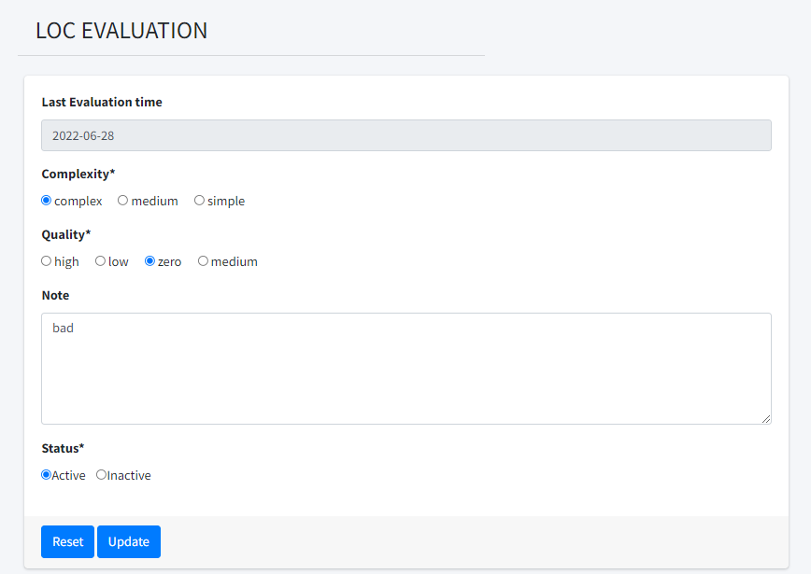

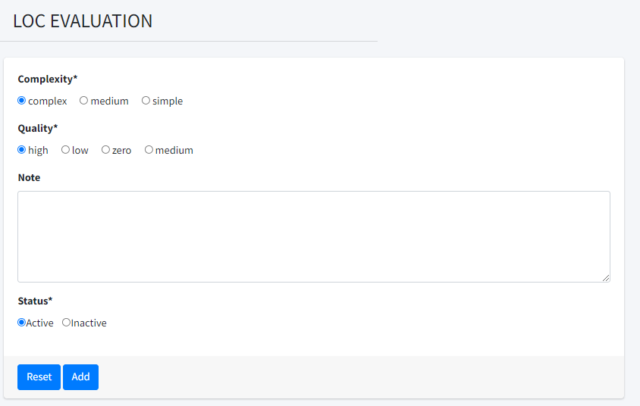

* Function Details:
* Show the loc evaluation for a tracking
* Get data from table loc_eval in database
* Trainer can access data of assigned class’s team (add, edit)
* Student can access data of allocated team only (view only)
* Complexity and Quality is came from table subject setting for each subject
* Add or update in here will update converted loc and grade in related data in table member_eval

### j. Team Evaluation

* Function trigger:

At home page, after login as role trainer or student, click on Team Evaluation on Dashboard to access to this screen

* Function description:

Show list of team evaluation, allow trainer to add, update.

* Screen layout*:*

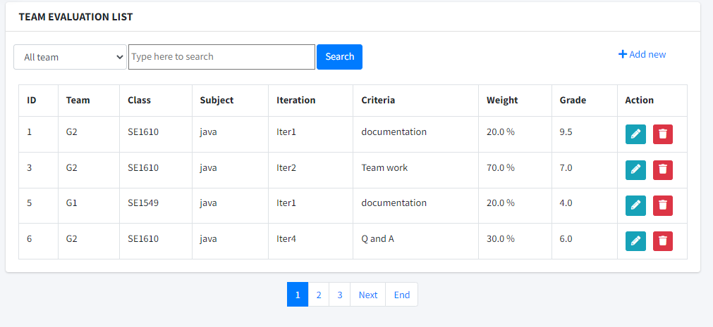

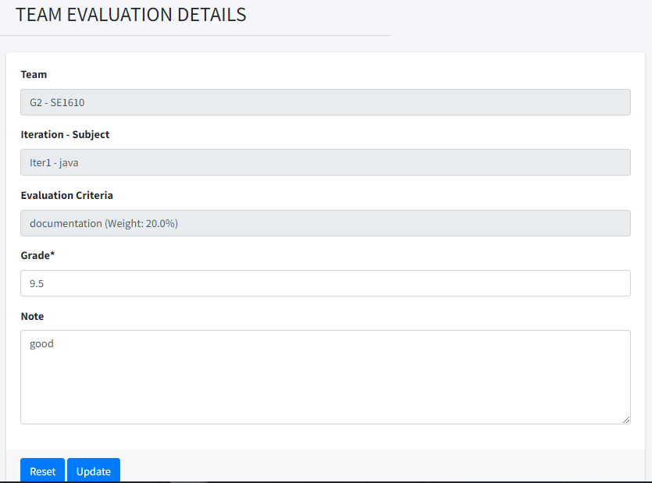

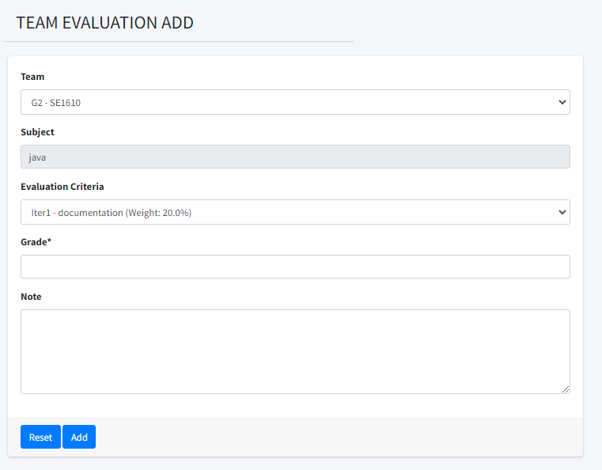

* Function Details:
  + Show list of team evaluation
  + Trainer can view, add, edit,delete of classes’ team
  + Student can view only data of allocated’s team
  + User data in table team_eval in database
  + Add: 
  + Edit: 
  + Delete: 
  + Any change, add here will update grade in table iteration_eval in database

### k. User Evaluation

* Function trigger:

At home page, after login with role trainer or student, click on User Evaluation on Dashboard to access this screen

* Function description:

Role: trainer, student

Show user evaluation with team grade and member grade for each criteria

* Screen layout:

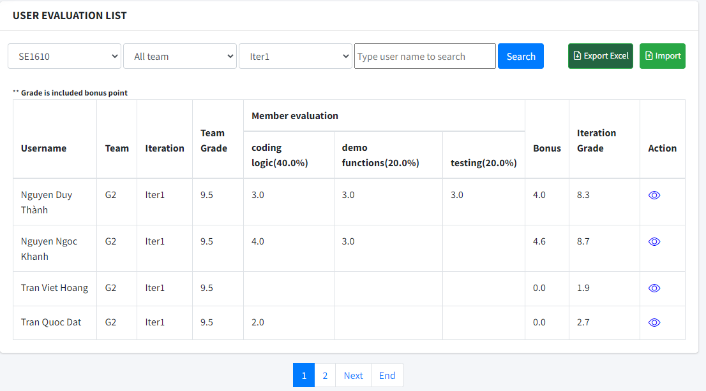

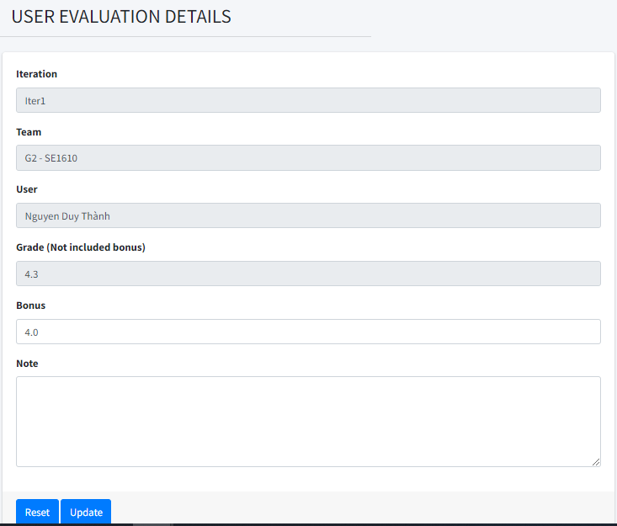

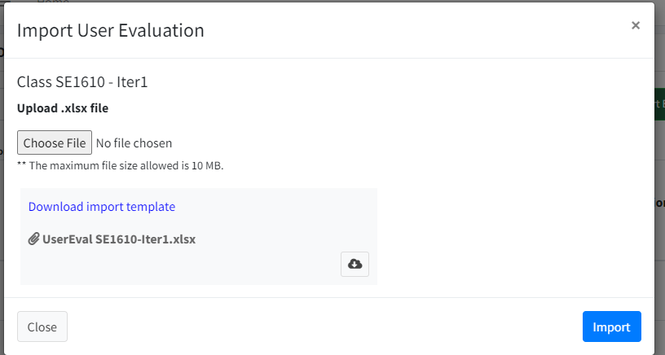

* Function Details:
  + Show user evaluation with combination of team evaluation and member evaluation
  + Student can access allocated team' data only (view only)
  + Trainer can access data of the assigned classes' teams (list/export/import/edit)
  + User data from 3 table: member_eval, iteration_eval in database
  + Allow search, filter.
  + Export xlsx (excel) file and import by xlsx file.
  + Update ,add, changes here will update grade in class_user table (ongoing_eval, final_pres_eval, final_topic_eval)

### l. Milestone Sync

* Function trigger: At Class details screen, there is a button name “Sync Milestone”. Click it to navigate to the milestone Sync screen
* Function description: Role: trainer

Show a list of current milestone on SPM database as well as milestone on said class in gitlab. Sync both SPM and gitlab ‘s milestone to become same

* Screen layout:

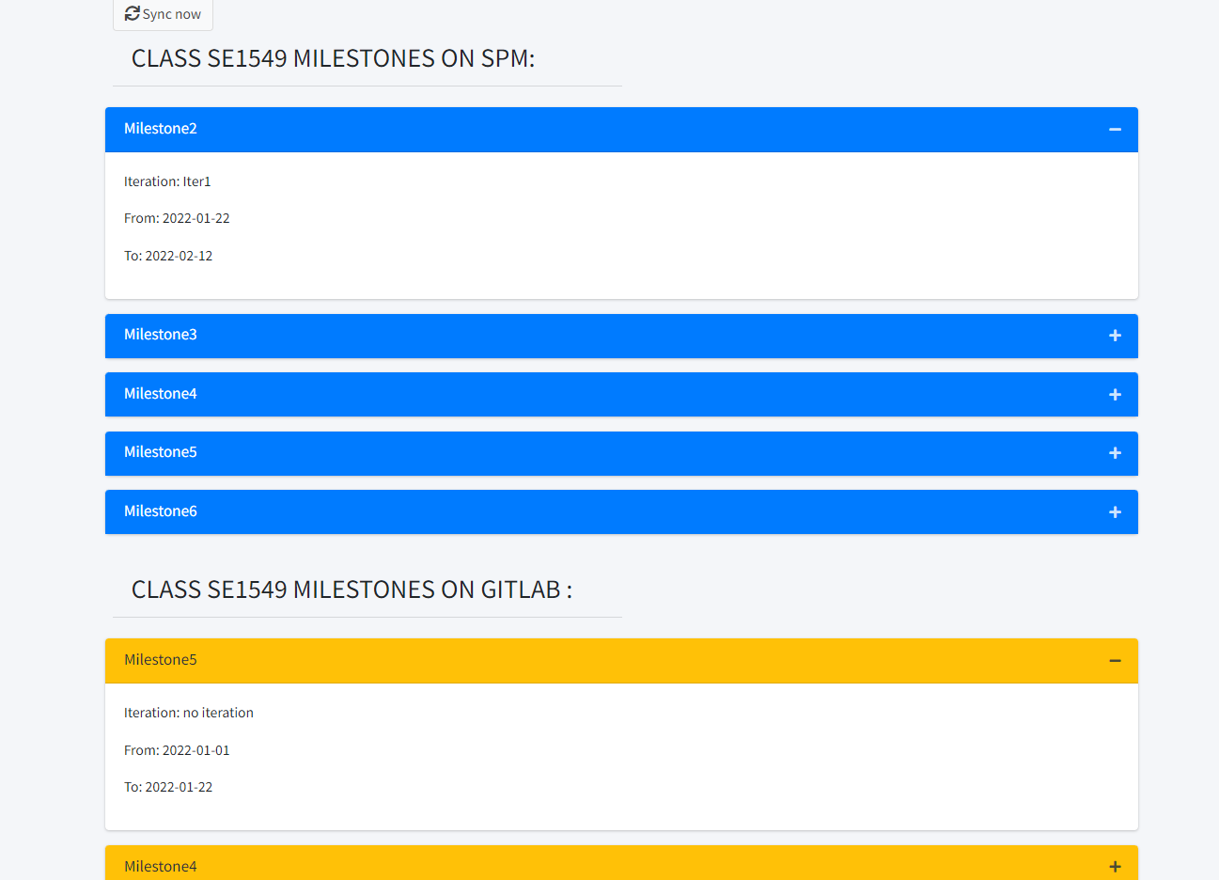

* Function Details:
  + Show current milestone on chosen class in SPM database.
  + Show milestone found on group that have same name on gitlab.
  + When sync all milestone on gitlab will be update to SPM with iteration=null and all milestone on SPM get update back to gitlab.

## 5. Student

### a. Feature List

* Function trigger:  When user(Student or Trainer) login in system and following the link:<http://localhost:8080/G6_swp/feature>  to come this screen.
* Function description:  Allow Trainer or Student can see this screen, in this screen, Student can access allocated team' data only, Trainer can access data of the assigned classes' teams.
* Screen Layout:

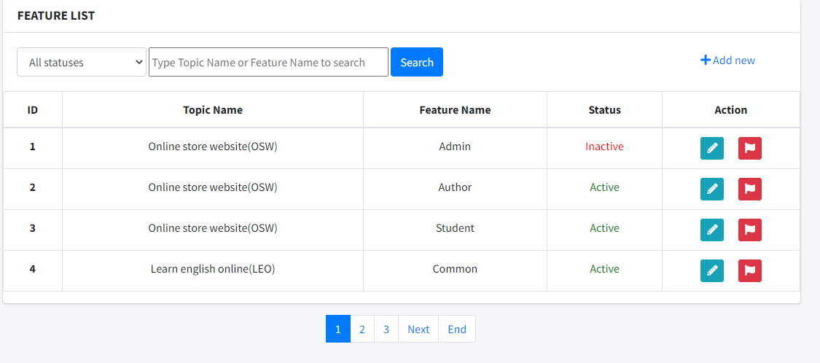

* Function Details:

About this screen, if you wanted to sort by Status or search by  Topic name or Feature name you just select or type in blank space, click button SEARCH to sort and find information that you want. Or when you want to add new Feature, you just click on Add new -> this action will allow your add new feature. About column Action you can change Status, if it is Active you can change it to Inactive with 1 click. Finally, Detail will lead you to another screen to view all information of these subjects and you can also change and update them.

### b. Feature details

* Function trigger:  when you click to Detail of each subject in each feature in column Action, you can get into screen to see the information of Feature.
* Function description: Allow Trainer and Student can see this screen, in this screen, Trainer can update information about feature name, and status.
* Screen layout:

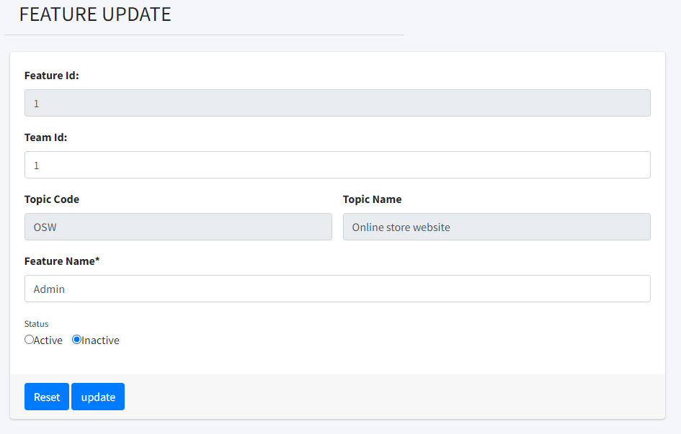

* Function Details**:** In this screen, it will show all information that features have and you can change information.

### c. Function List

• Function trigger: At the Home page, after successfully logging in with a Trainer or Student account, there will be a link called Dashboard and click on it, when you get to the Dashboard screen there will be a link called "Function" when you click on it. will lead the user to the "Function List" screen.

• Function description: Help Trainer and students view Functions and Function information that students have created. The interface includes functions: data filtering, Function information, index information page, operations (edit, deactivate) and Import / Export and add new buttons.

• Screen layout:

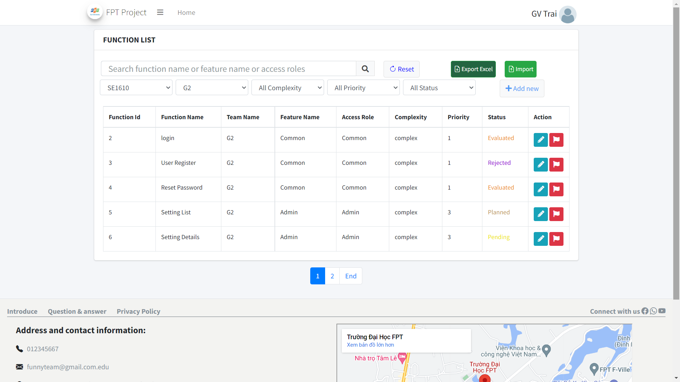

• Function Details:

o Display all Function in the Trainer or Student class : Function Id, Function, Name, Team Name, Feature Name, Access Role, Complexity, Priority,Status.

o Using the data in the “Function” table in the database

o Filter by Class code, Team Code, Class Term, Complexity,Priority, status.

o Import/export Function.

o Can link to details, update page and add new.

o Can change Function status

### d. Function Details

• Function trigger: At the Home page, after successfully logging in with a Trainer or Student account, there will be a link called Dashboard and click on it, when you get to the Dashboard screen there will be a link called "Function" when you click on it. will lead the user to the "Function List" screen, then click the pen icon button to go to the Function detail page.

• Function description: help Trainer and Students view detailed information of Function. The interface includes the following functions: Team Name, Feature Name, Function Name, Access Roles, Complexity, Priority, Status, Description

• Screen layout:

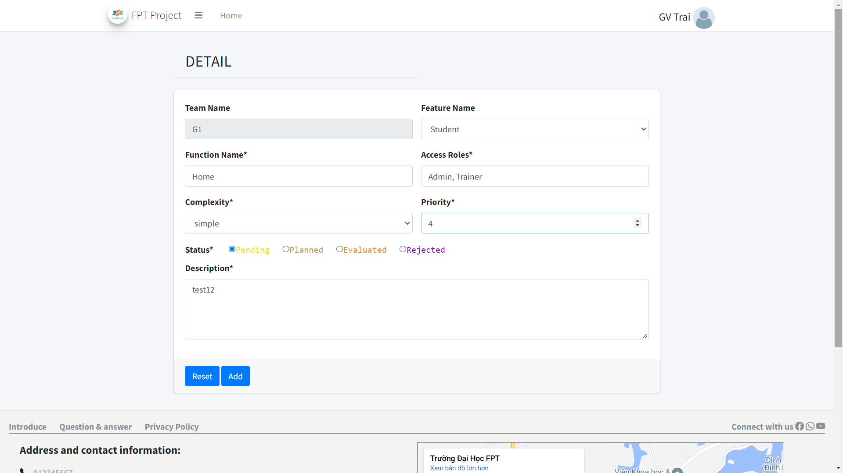

• Function Details:

o Display all details of a Function: Team Name, Feature Name, Function Name, Access Roles, Complexity, Priority, Status, Description.

o Using the data in the “Function” table in the database

o Can change Function information

### e. Function Export

• Function trigger: At the Home page, after successfully logging in with a Trainer or Student account, there will be a link named Dashboard and click on it, when the Dashboard screen comes out, there will be a link called "Function" when clicking on it. will lead the user to the "List of functions" screen, then click the "Export Excel" button to display a confirmation message to download the excel function file to the computer.

• Function description: Help Trainer or Student to export an excel file with the list of desired Functions.

• Screen layout:

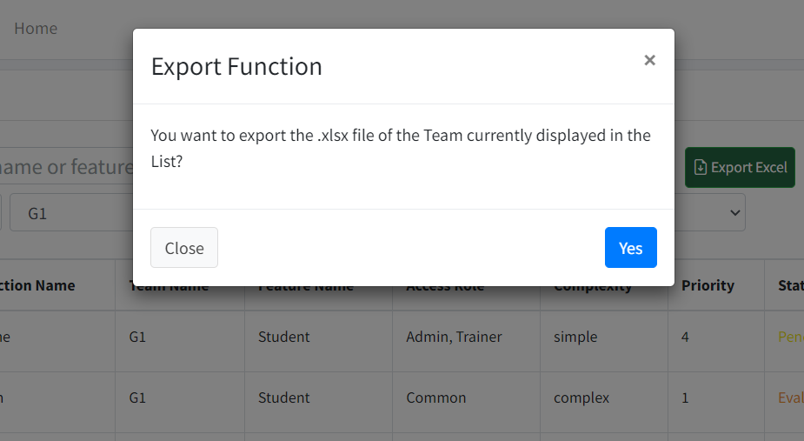

• Function Details:

o Export all the data of the Function that the user has filtered in the Function List section.

o Using the data in the “Function” table in the database

o Get the list of Function generators in excel form.

### f. Function Import

• Function trigger: At the Home page, after successfully logging in with your Trainer account, there will be a link called Dashboard and clicking on it, when you get to the Dashboard screen, there will be a link called "Function" when you click on it. will lead the user to the "Function List" screen, then clicking the Import button will bring up the Import screen.

• Function description: help User import excel file with Function list that User wants. The system excel file reads and updates the information in the Function table.

• Screen layout:

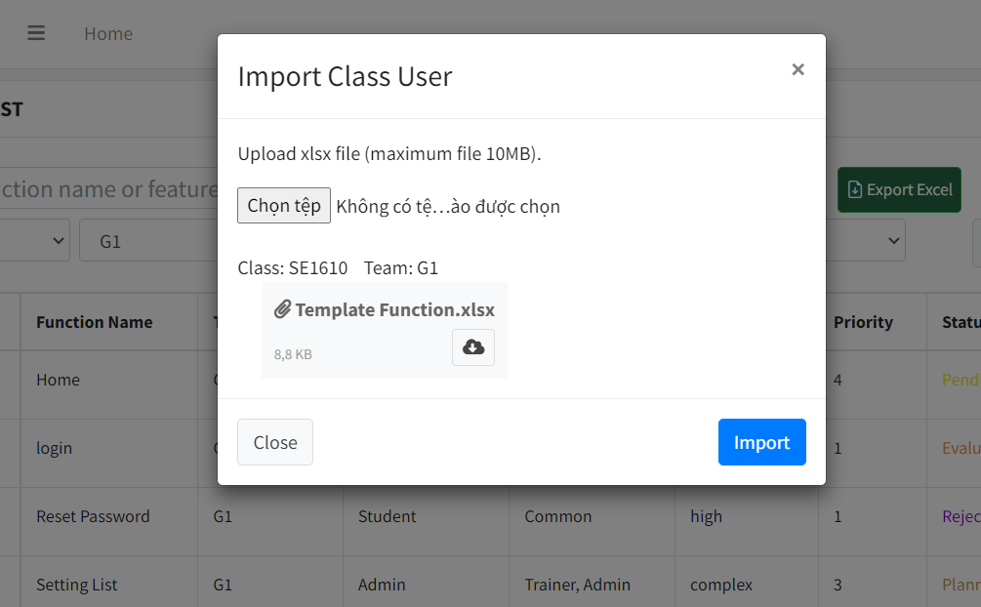

• Function Details:

o Display all information of User Functions and select the file you want to import.

o Use the data in the excel file to update the "Function" table information in the database.

### g. Issue List

• Function trigger: at the Home page, after successfully logging in with the account, there will be a link named Dashboard and clicking on it, when reaching the Dashboard screen, there will be a link named "Issue List" when clicking will lead the user to the Function Issue screen List.

• Function description: help trainer control team functions (issue_id, assignee_id, issue_type, issue_title, descript, gitlab_id, gitlab_url, created_at, due_date, team_id, milestone_id, function_ids, labels, status). The interface includes the following functions: filter data (filter statuses, enter Issue Title, User Name), display team data (Id, Issue title, User Name, Create Date, Due Date, Status) , action (edit, deactivate) and add Issue.

• Screen layout:

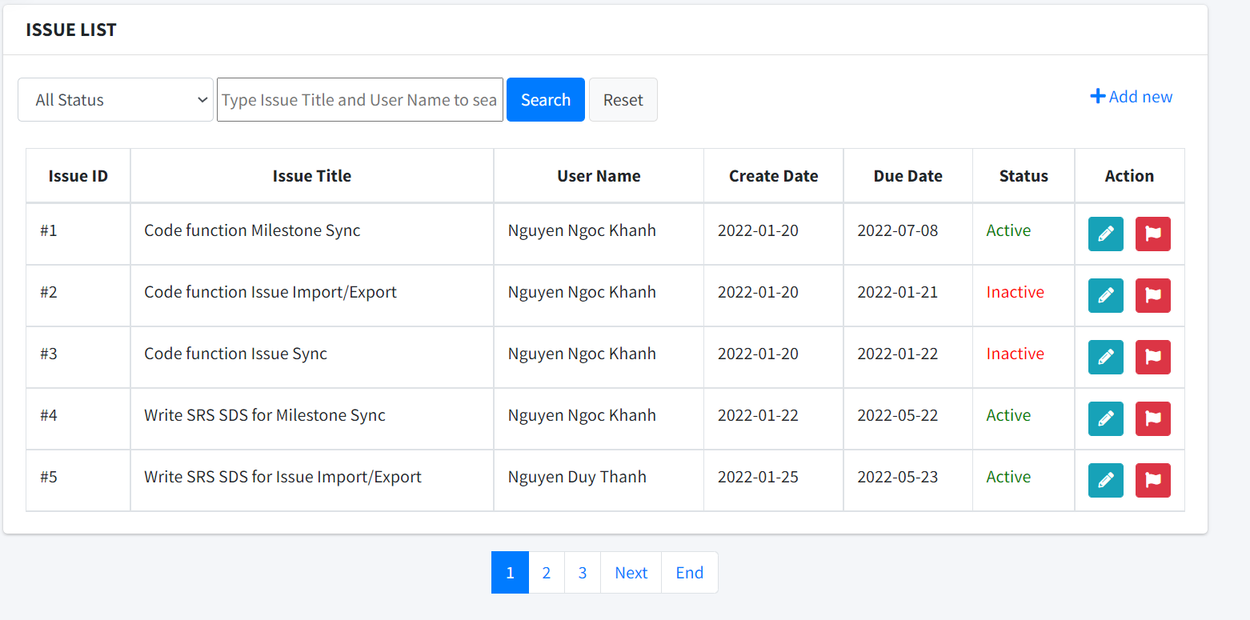

• Function Details:

O Display all Issue for Trainer, Student: Id, Issue title, User Name, Create Date, Due Date, Status

o Use data in table “issue” in database

o Filter by type, status or name

o Add new issue

o Can link to details, update page.

O Can delete issue

### h. Issue details

• Function trigger: continue the Function trigger of " Function Issue List" when at the screen of Issue List each line of setting information will have an Action column in the column there will be an "edit" button which will lead to the Issue Details screen of the user selected setting.

• Function description: View and edit detailed data of each " Issue ". the interface will display data in the value of input and admin can edit that data (Setting Name, Issue Title, Gitlab ID, GitLab URL, Due Date, milestone,Function ID, Topic Name, Label, Issue Descript, Status ),"Status" has 2 options active or Inactive , after editing can be done. Click the submit button to save the edit.

• Screen layout:

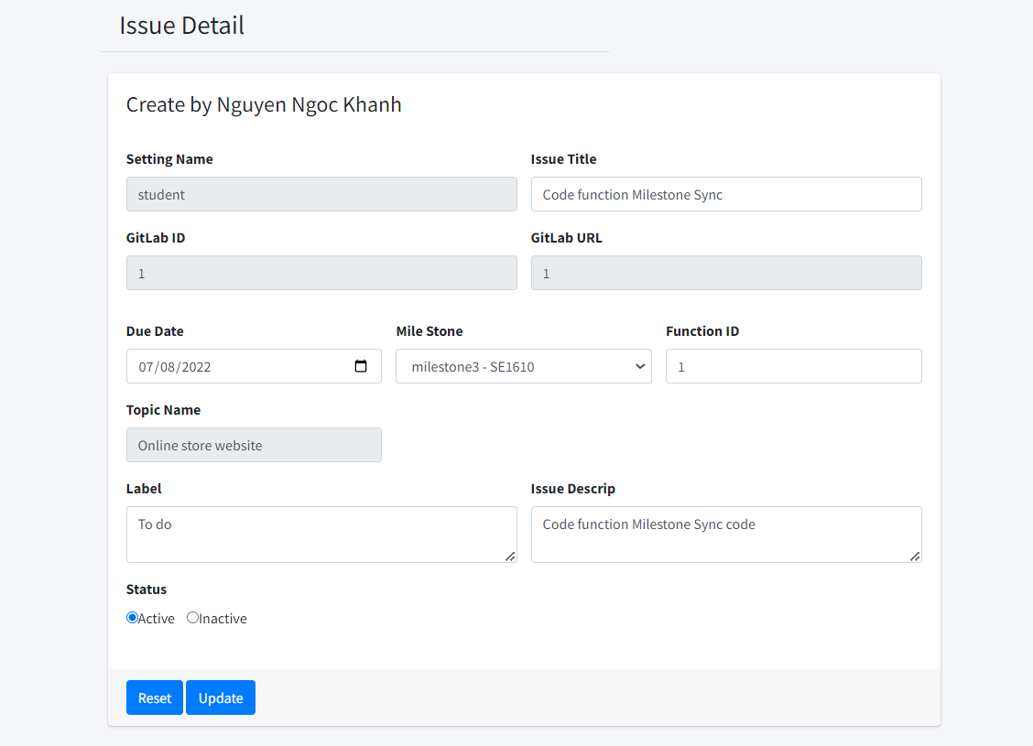

• Function Details:

O See details of Issue

O Can also update Issue in here: update Issue Title, Status, Due Date, milestone, Function ID, Label, Issue Descript, Status

O By click on submit, data will be update in table “Issue” in database

### i. Issue sync

• Function trigger: continue the Function trigger of " Function Issue List" when at the screen of Issue List there is a button name ”Sync Issue with gitLab” which lead to screen Issue sync. User choose team to sync

• Function description: Role: trainer, student

Sync a team Issue with gitlab assume that said team is a subgroups of a class that exist on gitlab.

• Screen layout:

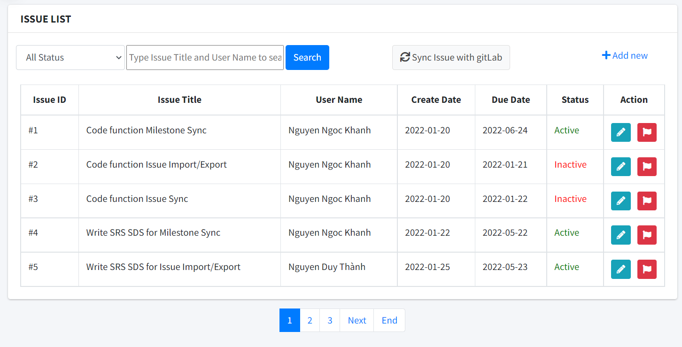

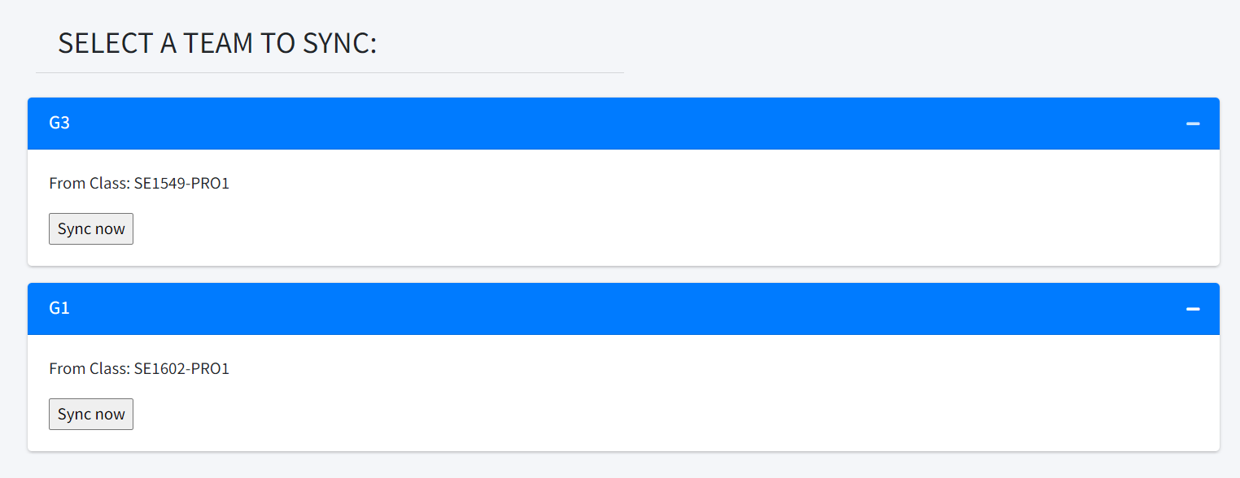

• Function Details:

O See all team that user is in or in charge of.

O Get all Issue on chosen team which don’t have gitlab_id and push to gitlab, update that issue’s gitlab_id

O Get all Issue on gitlab that Issue’s title doesn’t exist in SPM database and update to SPM database